In this open-source file, we have compared the precision of the proposed method (i.e., Adaptive Multistage RLC Circuit and Neural Network-Based Stage-Wise Parameter Identification) with four recently reported methods in Table I: [22], [23], [25], and [30]. We chose these four methods for comparison because each one employs a distinct curve fitting technique. For example, [22] utilizes the Monte Carlo algorithm (MCA), [23] employs a neural network (NN) algorithm, [25] uses a genetic algorithm (GA), and [30] employs an analytical method. Additionally, each method represent the state-of-the-art technology for its respective curve fitting technique.

Explanation regarding ways to compare the precision:

There are two straightforward ways to compare the precision: the first is to implement our modeling method based on the respective dataset in each reference and then compare it with the methods reported in each reference; the second is to implement the modeling methods reported in each reference based on our dataset and then compare them with our method. However, the first way requires us to pre-obtain the exact motor impedance data used for validation in all these references, which is often difficult due to intellectual property protection or other similar reasons. The second way faces similar issues, as it requires us to pre-obtain all necessary details for model construction to accurately implement the reported methods. Additionally, even if we implemented these reported methods using our dataset, we might still face doubts such as, "The accuracy issues might not be due to the reported methods themselves, but due to the additional discrepancies introduced during our model construction (e.g., not obtaining precise and sufficient necessary details)." Therefore, we seek the reviewer's understanding that we did not choose the above-mentioned two ways for precision comparison. As an alternative, we selected a relatively fair but feasible way to compare the precision, as described below:

* Step 1: Based on our dataset, we apply the proposed method and try to use a model with a similar number of stages to estimate the same type of motor impedances over the same frequency range reported in each reference.
* Step 2: Under the pre-condition specified in Step 1, we compare the accuracy of the estimated results using the proposed method with those obtained using the reported methods. It should be noted that the estimated results using the reported methods are based on their respective datasets. To ensure similarity between the datasets used by the proposed method and the reported methods in each comparison, and to maintain fairness as much as possible, we attempt to use motors with similar power ratings in each comparison.

The comparison between the proposed method and each reported method is detailed as follows.

Comparison between the proposed method with the method reported in [22]:

Step 1: As shown in Figures R1(a) and R1(b), the model in [22] has a similar number of stages to the proposed model with two levels. Therefore, both models are used for comparison. The model in [22] validates the estimated CM impedance magnitude of a Y-connected motor over the frequency range from 9 kHz to 30 MHz. To ensure a fair comparison, the same type of motor impedance over the same frequency range is estimated using the proposed model. Considering the power rating of the motor used for validation in [22] is 3.3 kW, a motor with a similar power rating (5.5 kW) is selected for validating our proposed model.

Step 2: Figures R1(c) and R1(d) show the estimated CM impedance magnitudes using the models in Figures R1(a) and R1(b), respectively. The respective measurement results are also included in Figures R1(c) and R1(d) for reference. As seen, due to the similar power ratings of the two motors, their CM impedance amplitude curves exhibit very similar characteristics across the entire frequency range from 9 kHz to 30 MHz. This further verifies the relative fairness of the comparison way we adopted. Using the measured results as references, the averaged magnitude relative error (*ema*) of the proposed model is calculated to be 1.45% (i.e., 0.28 dB), while the *ema* of the model in [22] is not mentioned. However, it is evident from Figures R1(c) and R1(d) that both estimated CM impedance amplitude curves exhibit good agreement with their respective reference results and captured most of the local variations of their curves, verifying their high accuracy. Therefore, the “Accuracy” of the method reported in [22] is listed as “High” in Table I.

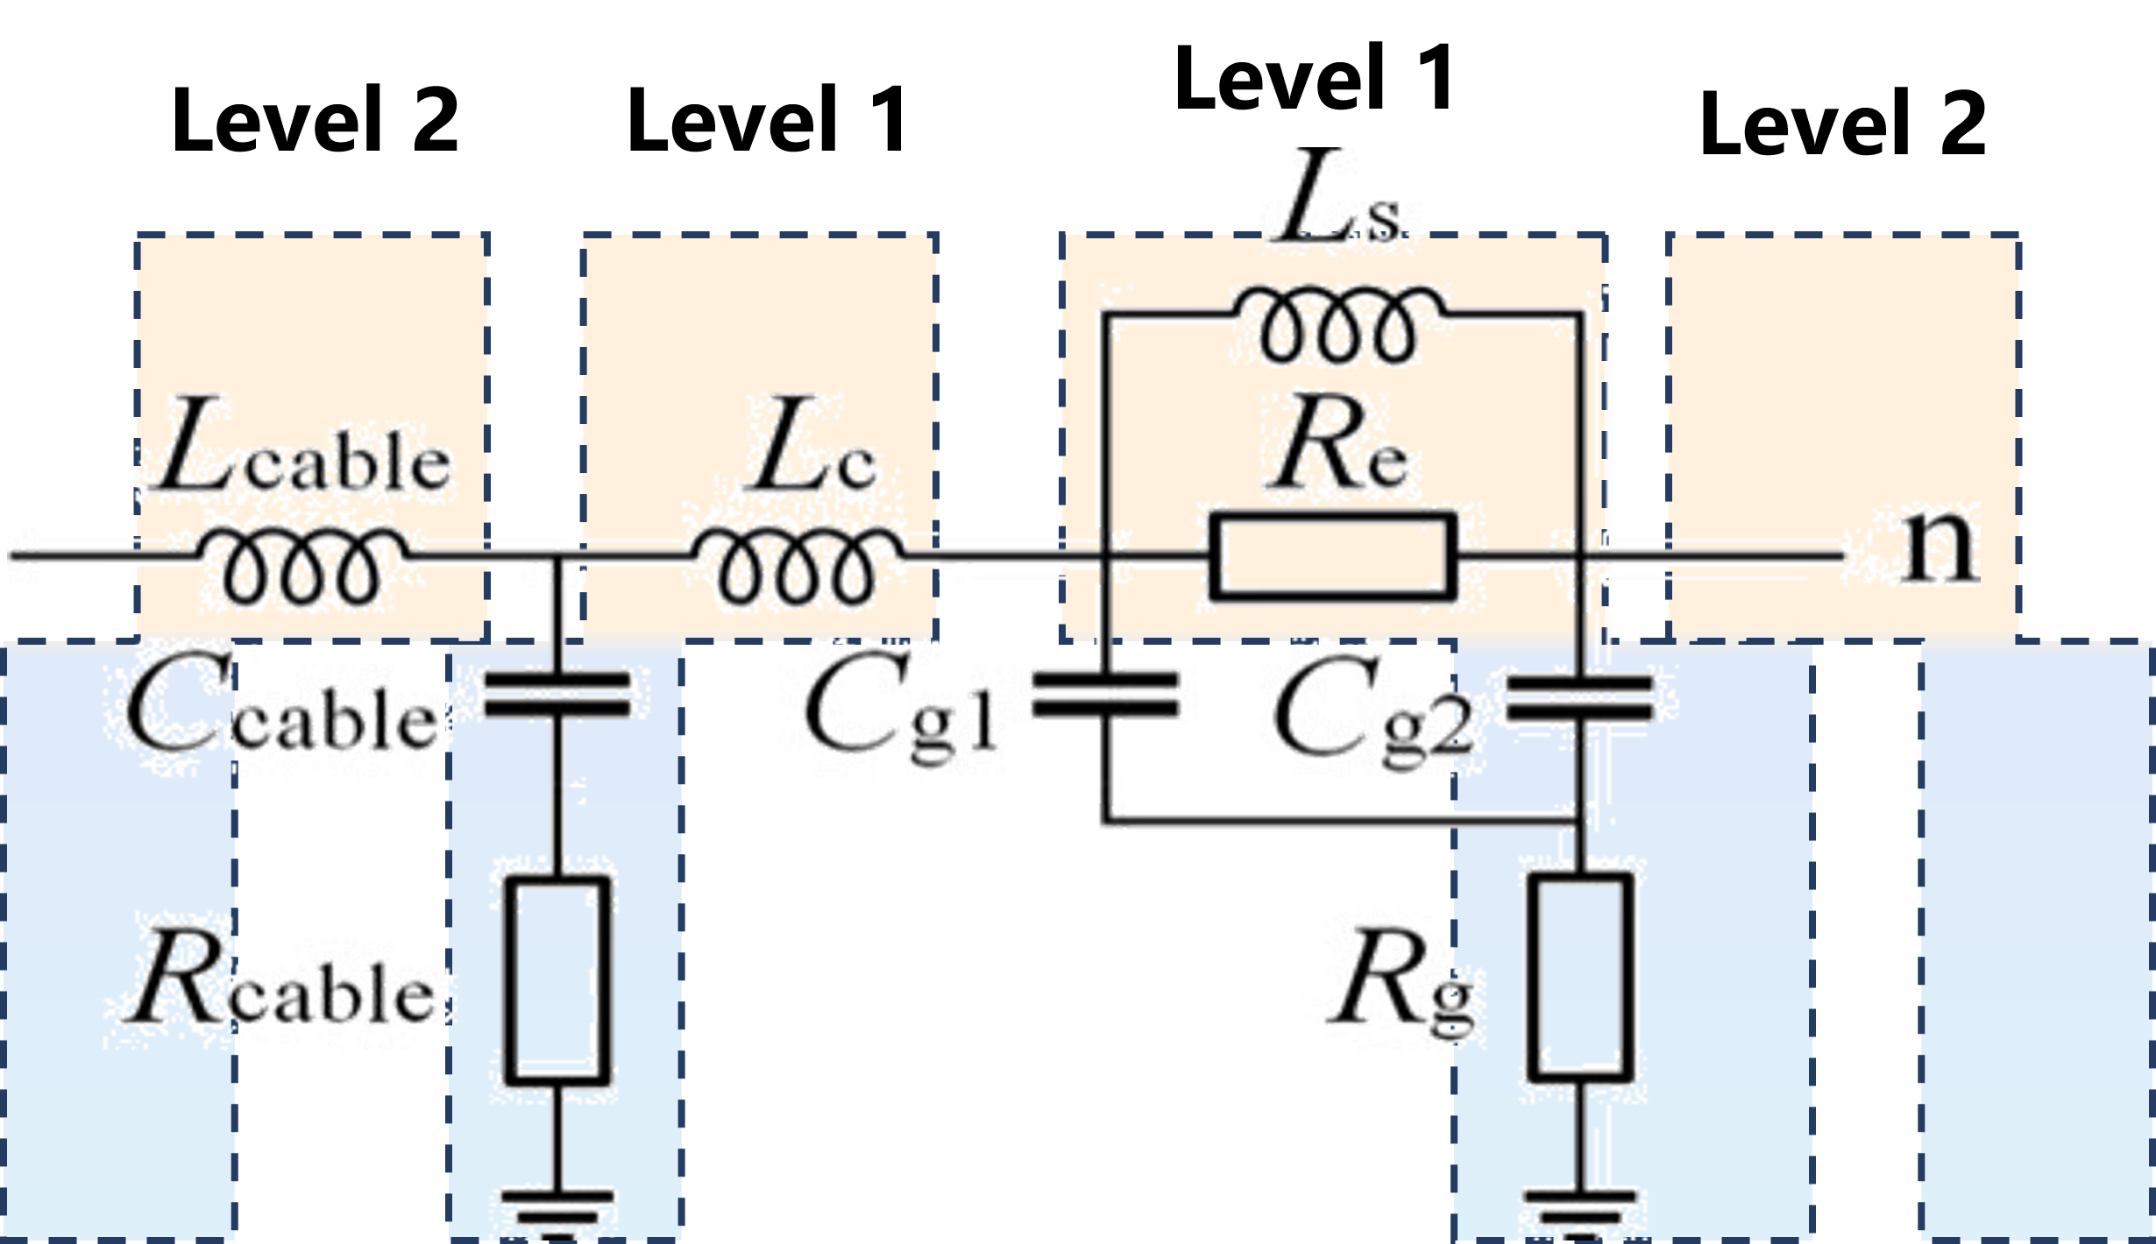 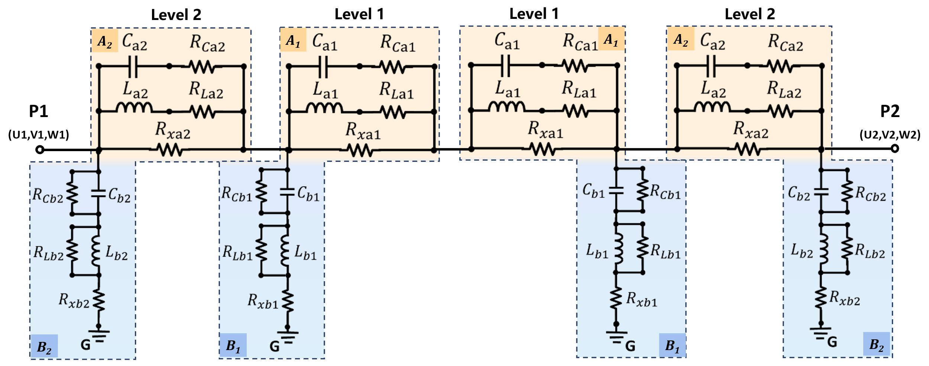

(a) (b)

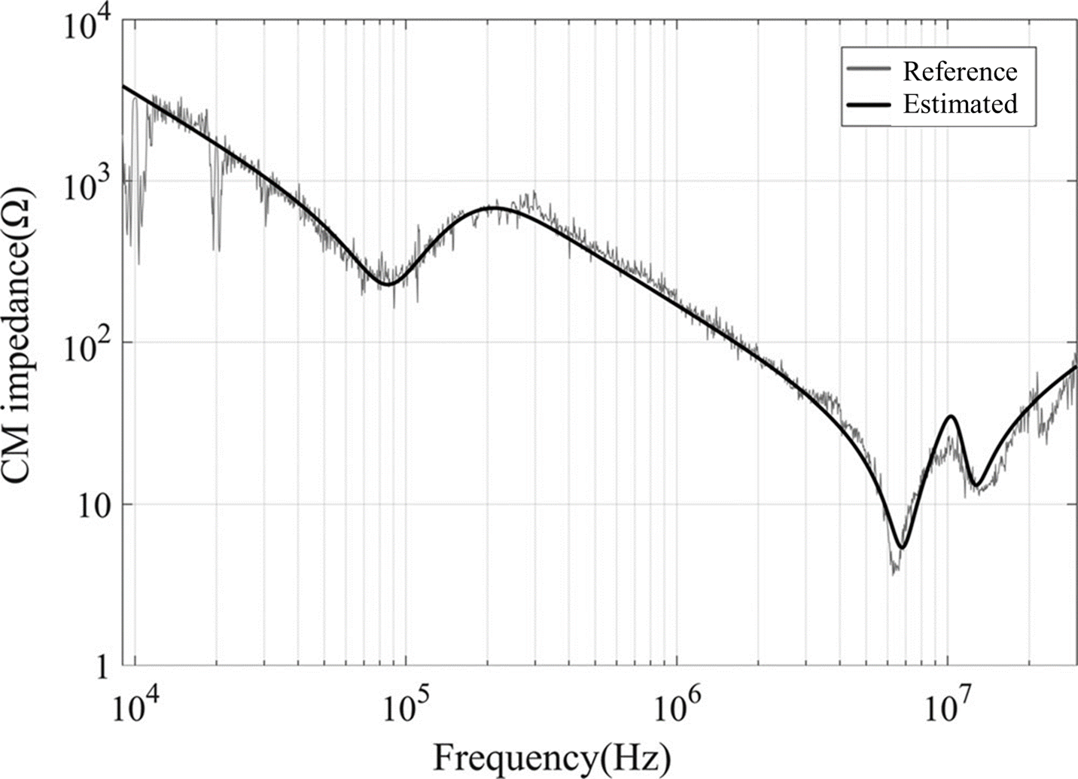 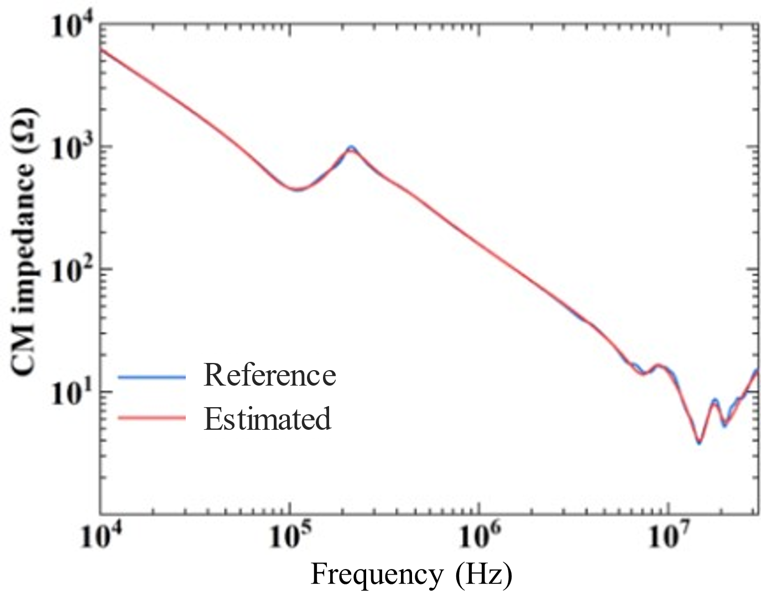

(c) (d)

Figure R1. (a) Model in [22]. (b) Proposed model with two levels. (c) Estimated CM impedance magnitude of a 3.3-kW motor (Y-connection) using the model in [22]. (d) Estimated CM impedance magnitude of a 5.5-kW motor (Y-connection) using the proposed model.

Comparison between the proposed method with the method reported in [23]:

Step 1: As shown in Figures R2(a) and R2(b), the model in [23] has a similar number of stages to the proposed model with three levels. Therefore, both models are used for comparison. The model in [23] validates the estimated SP, PG, CM, and DM impedances of a motor over the frequency range from 1 kHz to 30 MHz. To ensure a fair comparison, the same type of motor impedances over the same frequency range are estimated using the proposed model. Considering the power rating of the motor used for validation in [23] is 5.5 kW, a motor with the same power rating is selected for validating our proposed model.

Step 2: The estimated results for the SP, PG, CM (Y-connection), DM (Y-connection), CM (∆-connection), DM (∆-connection) impedances of the motors are shown in Figures R2(c) to R2(l). The respective measurement results are also included in the figures for reference. Using the measured results as references, the averaged magnitude relative error (*ema*) and the averaged phase absolute error (*epa*) of the above impedances using both models are listed in Table R1. It is seen that both models exhibited rather high accuracy (i.e., *ema* ≤ 2.8 dB and *epa* ≤ 13.9 deg). Therefore, the “Accuracy” of the method reported in [23] is listed as “High” in Table I of the manuscript. Although both models show high accuracy, it can be seen from Figures R2(c) to R2(h) that our proposed model is able to capture more local variations in the SP and PG impedance curves of each phase. This is because the proposed model has a higher circuit order and thus greater flexibility in curve fitting.

Table R1. Comparison of the estimated errors using the proposed model with three stages and the model in [23]

|  |  |  |  |  |  |  |  |  |  |  |
| --- | --- | --- | --- | --- | --- | --- | --- | --- | --- | --- |
|  | SP and PG for all phases | | CM (Y) | | DM (Y) | | CM (Δ) | | DM (Δ) | |
| *ema* (dB) | *epa* (deg) | *ema* (dB) | *epa* (deg) | *ema* (dB) | *epa* (deg) | *ema* (dB) | *epa* (deg) | *ema* (dB) | *epa* (deg) |
| Model in [23] | 1.5 | 9.0 | 2.4 | 12.5 | 2.3 | 13.9 | 2.8 | 11.4 | 1.8 | 13.5 |
| Proposed model | 0.3 | 2.9 | 2.2 | 8.3 | 2.0 | 9.2 | 2.3 | 5.1 | 1.5 | 6.0 |

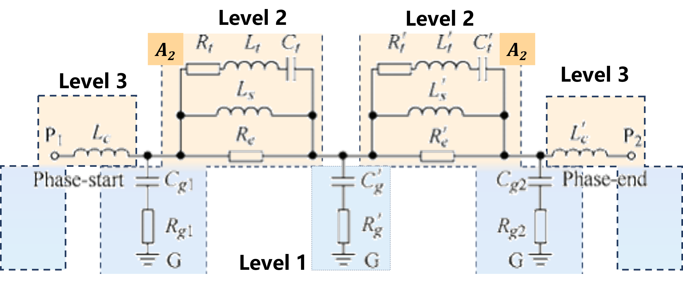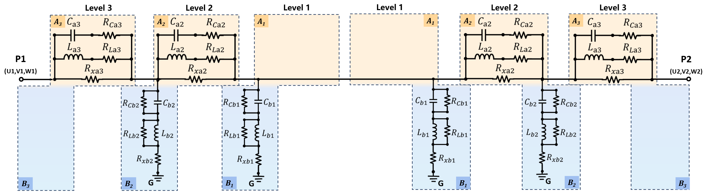

(a) (b)

 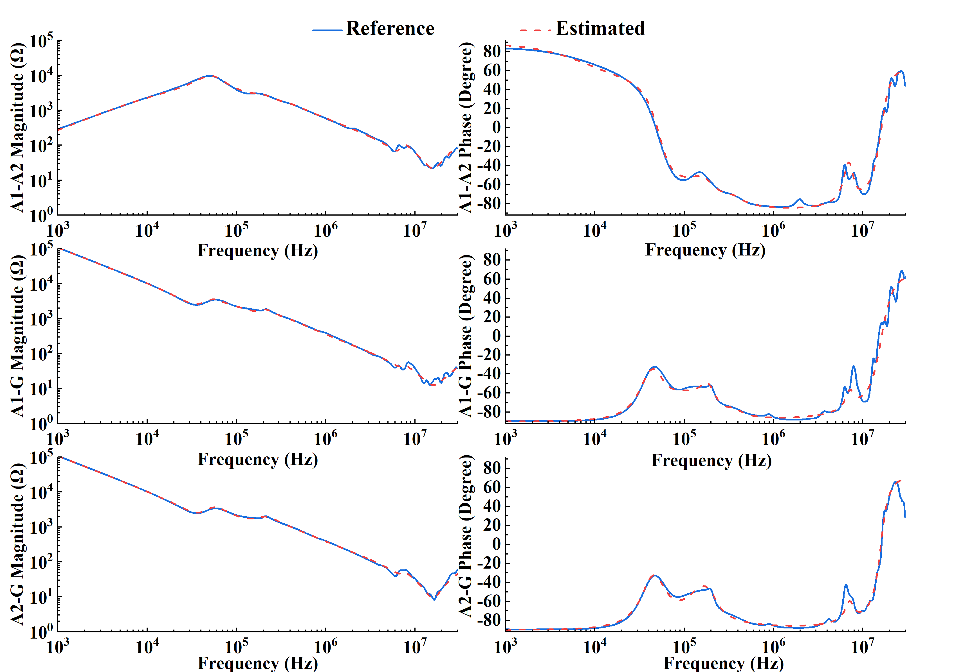

(c) (d)

 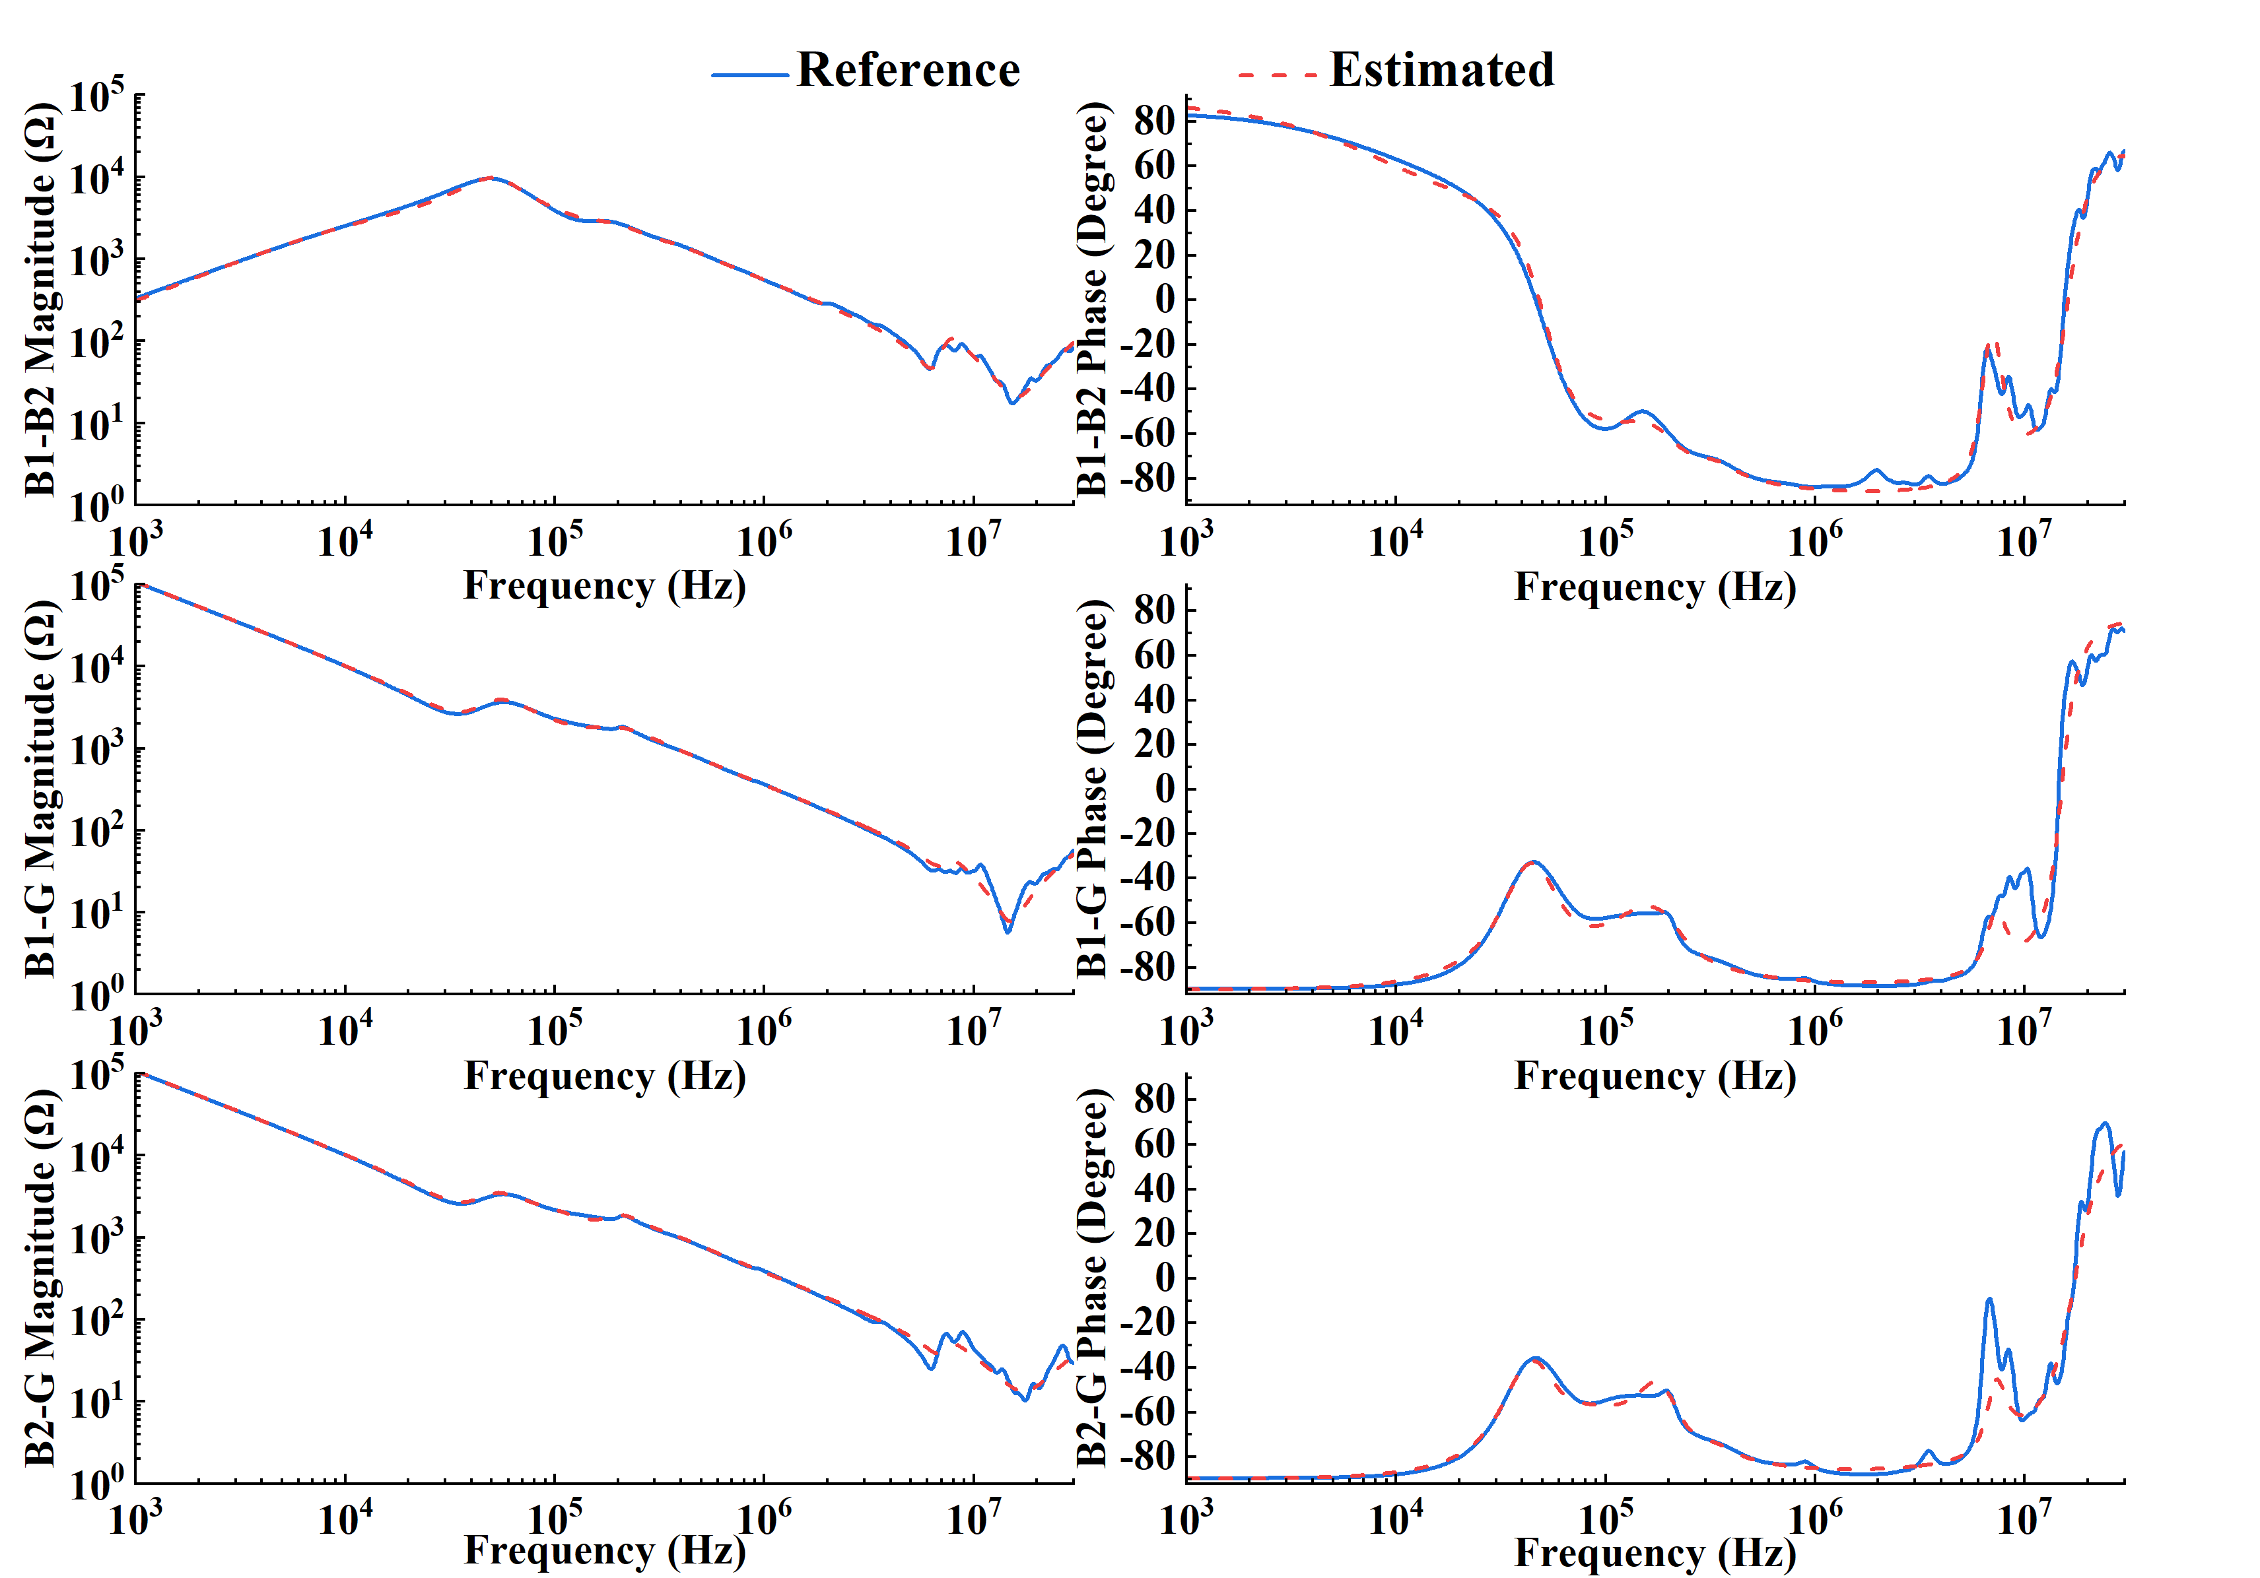

(e) (f)

 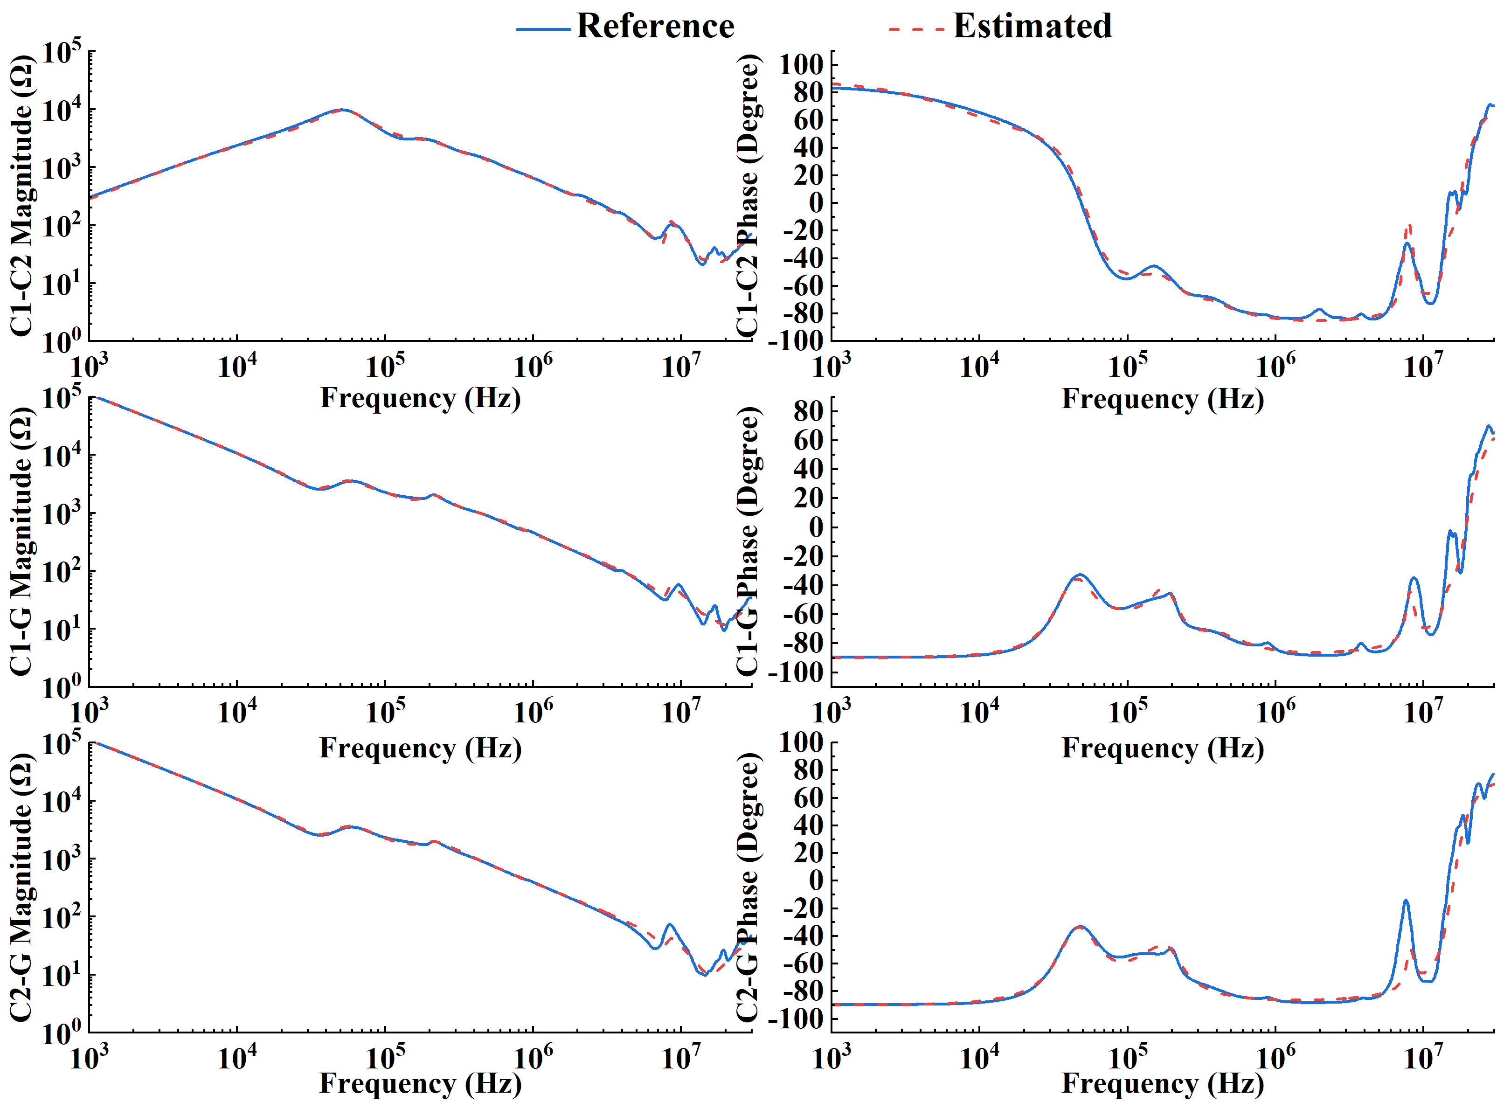

(g) (h)

 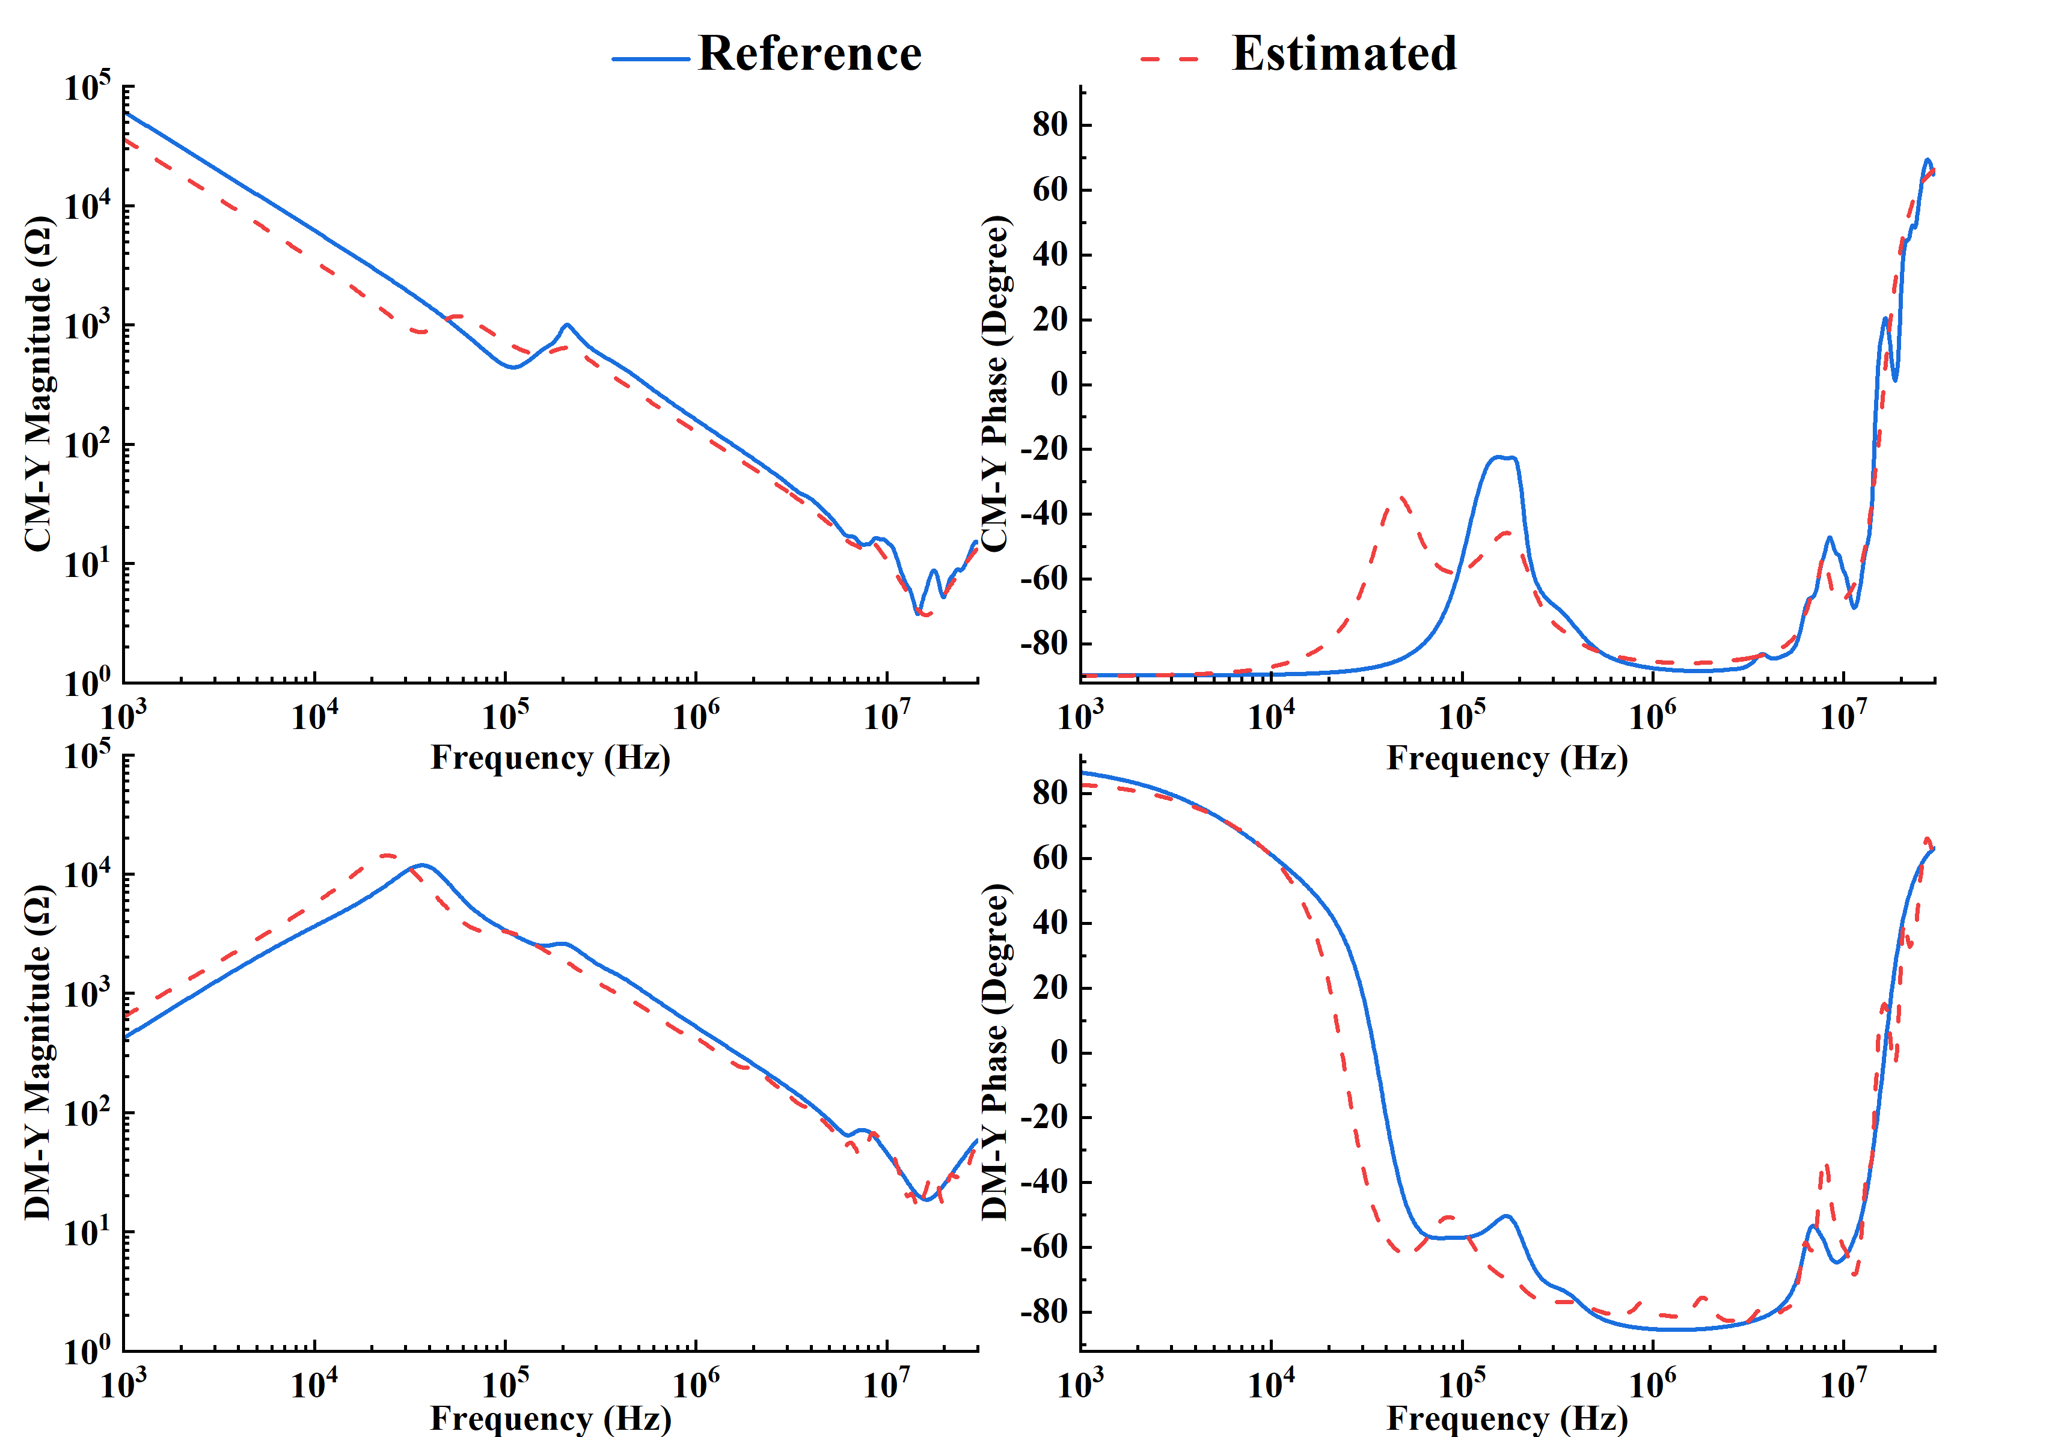

(i) (j)

 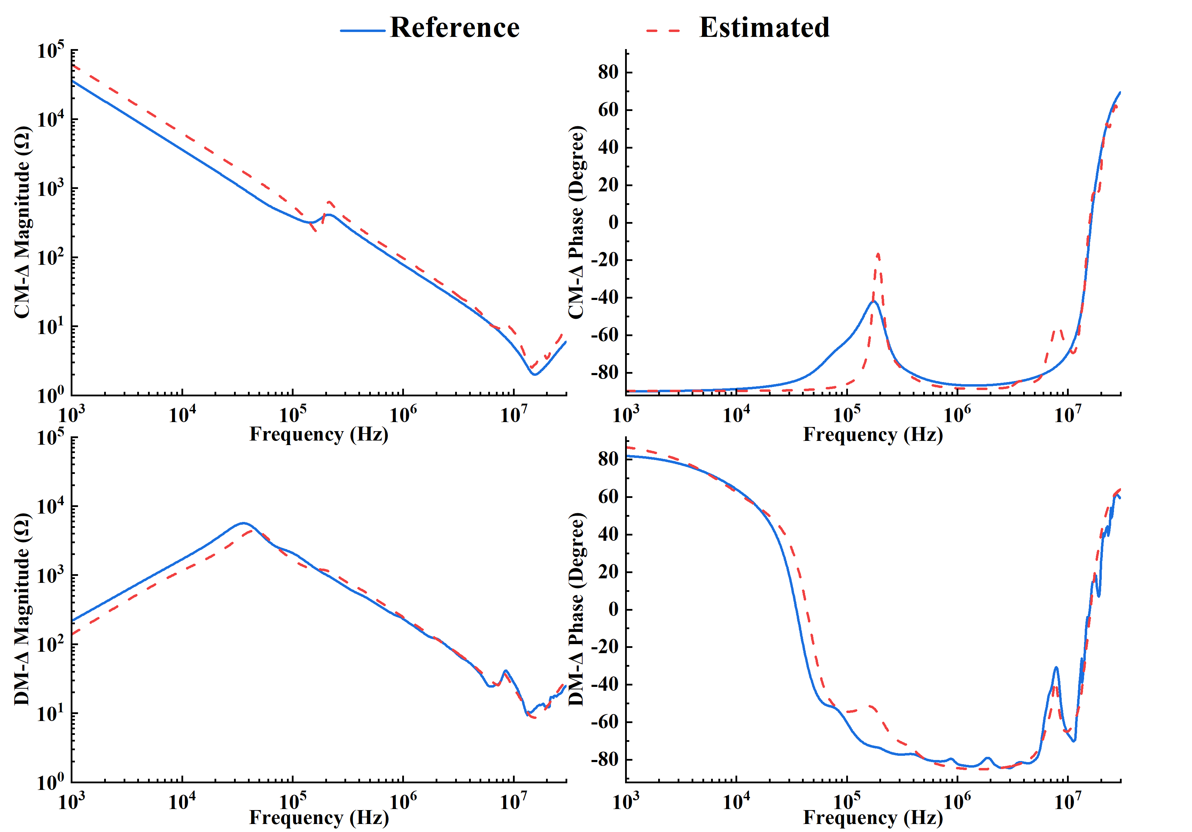

(k) (l)

Figure R2. (a) Model in [23]. (b) Proposed model with three levels. (c) Estimated SP and PG impedances of phase A of a 5.5-kW motor using the model in [23]. (d) Estimated SP and PG impedances of phase A of a 5.5-kW motor using the proposed model. (e) Estimated SP and PG impedances of phase B of a 5.5-kW motor using the model in [23]. (f) Estimated SP and PG impedances of phase B of a 5.5-kW motor using the proposed model. (g) Estimated SP and PG impedances of phase C of a 5.5-kW motor using the model in [23]. (h) Estimated SP and PG impedances of phase C of a 5.5-kW motor using the proposed model. (i) Estimated CM and DM impedances (Y-connection) of a 5.5-kW motor using the model in [23]. (j) Estimated CM and CM impedances (Y-connection) of a 5.5-kW motor using the proposed model. (k) Estimated CM and DM impedances (∆-connection) of a 5.5-kW motor using the model in [23]. (l) Estimated CM and DM impedances (∆-connection) of a 5.5-kW motor using the proposed model.

Comparison between the proposed method and the method in [25]:

Step 1: As shown in Figures R3(a) and R3(b), the model in [25] has a similar number of stages to the proposed model with two levels. Therefore, both models are used for comparison. The model in [25] validates the estimated CM impedance of a motor over the frequency range from 10 kHz to 30 MHz. To ensure a fair comparison, the same type of motor impedance over the same frequency range is estimated using the proposed model. It should be noted that the proposed model was original designed to fit both SP and PG impedance curves and then calculate the CM impedance based on the fitted results. Here, the proposed model is used to directly fit the CM impedance curve for a fair comparison. Additionally, since [25] did not provide information about the motor under test, such as its connection and power rating, three distinct motors covering a wide range of power ratings (1.1 kW to 22 kW) and different motor connections (Y and ∆) are used for validating our proposed model.

Step 2: The estimated results for the CM impedances of the motors are shown in Figures R3(c) to R3(f). The respective measurement results are also included in the figures for reference. Using the measured results as references, the estimation errors of the above models are compared in Table R2, evaluated by the Weighted Summation of Mean Squared Error (WSMSE) defined in [25]. It is seen that both models exhibited high accuracy (i.e., WSMSE≤ 2.35). Therefore, the “Accuracy” of the method reported in [25] is listed as “High” in Table I of the manuscript. In addition, it can be seen from Table R2 that the WSMSE can be significantly reduced with an increase in the stage level *k* (e.g., from 2 to 4 or 6) using our proposed model.

Table R2. Comparison of the estimated errors using the proposed model and the model in [25]

|  |  |  |  |  |  |  |  |
| --- | --- | --- | --- | --- | --- | --- | --- |
|  | Motor  power rating | Motor  connection  (MC) | WSMSE in [25] = MSE(|*Z*|) +*α*MSE(∠Z) | | | | |
| Weights between magnitude and phase (*α*) | Number of sampled frequency points  (*Nm*) | WSMSE at different stage level *k* | | | |
| *k =* 2 | *k =* 4 | *k =* 6 | |
| Model in [25] | N/P | N/P | 17.38 | 96 | 2.35 | - | - | |
| Proposed model | 1.1 kW | Y | 17.38 | 150 | 1.23 | 0.35 | 0.08 | |
| 5.5 kW | ∆ | 17.38 | 150 | 1.42 | 0.68 | 0.07 | |
| 22 kW | Y | 17.38 | 150 | 1.84 | 0.50 | 0.05 | |

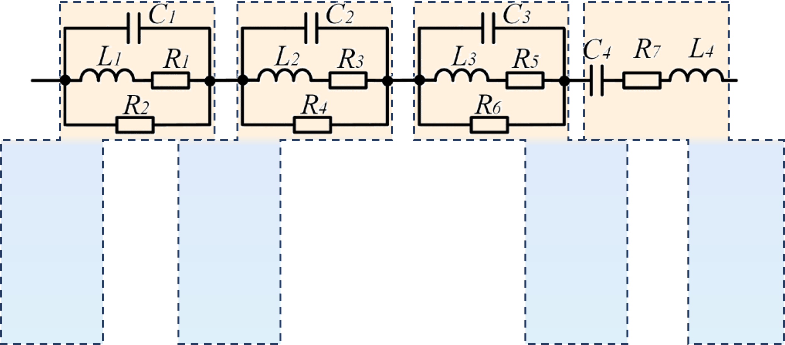 

(a) (b)

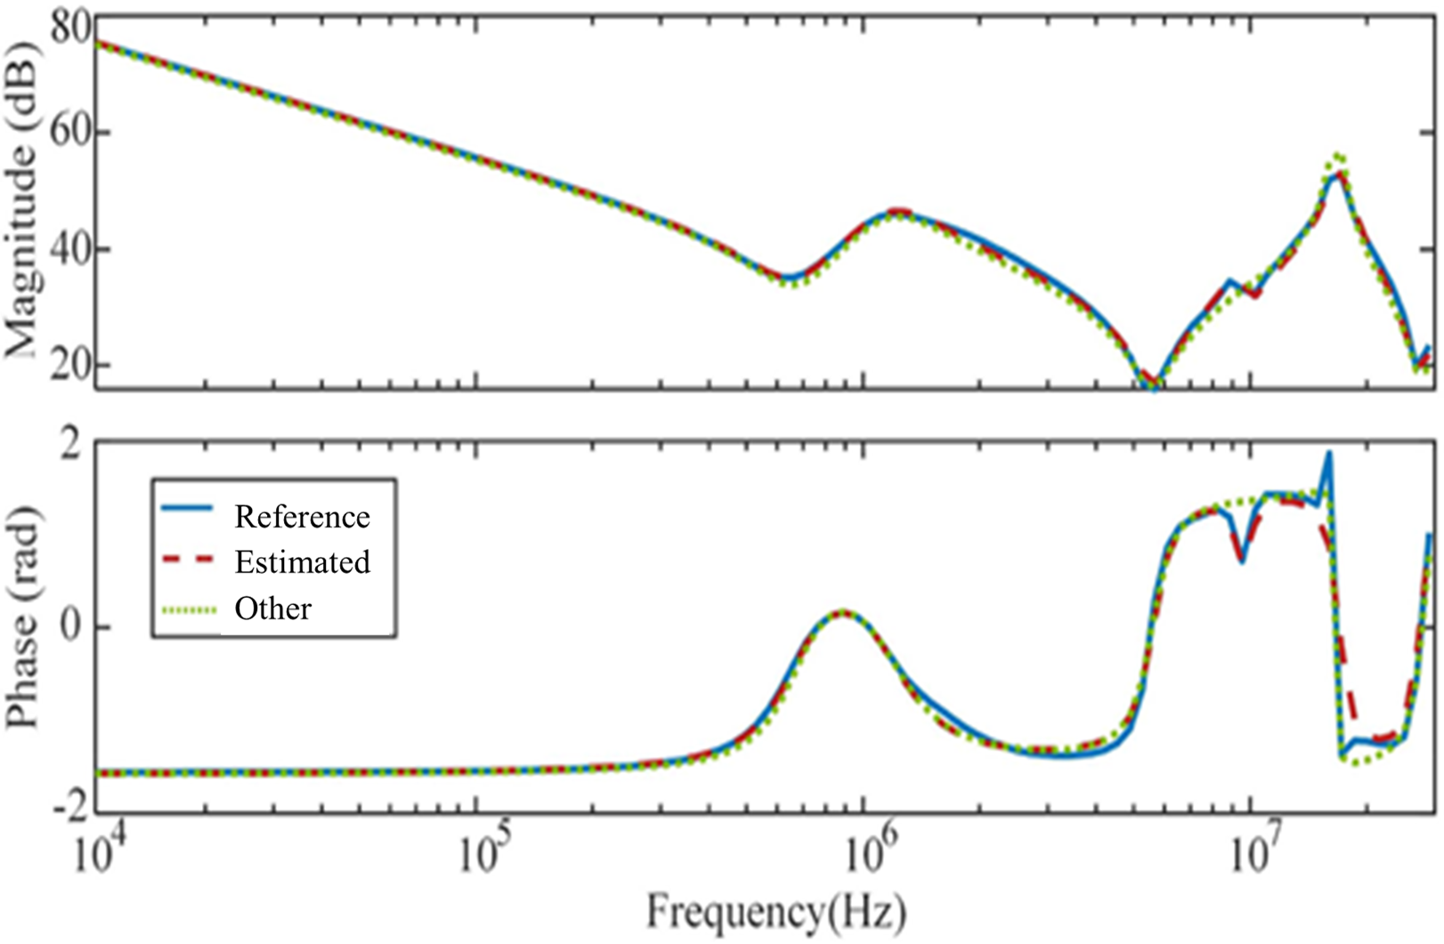 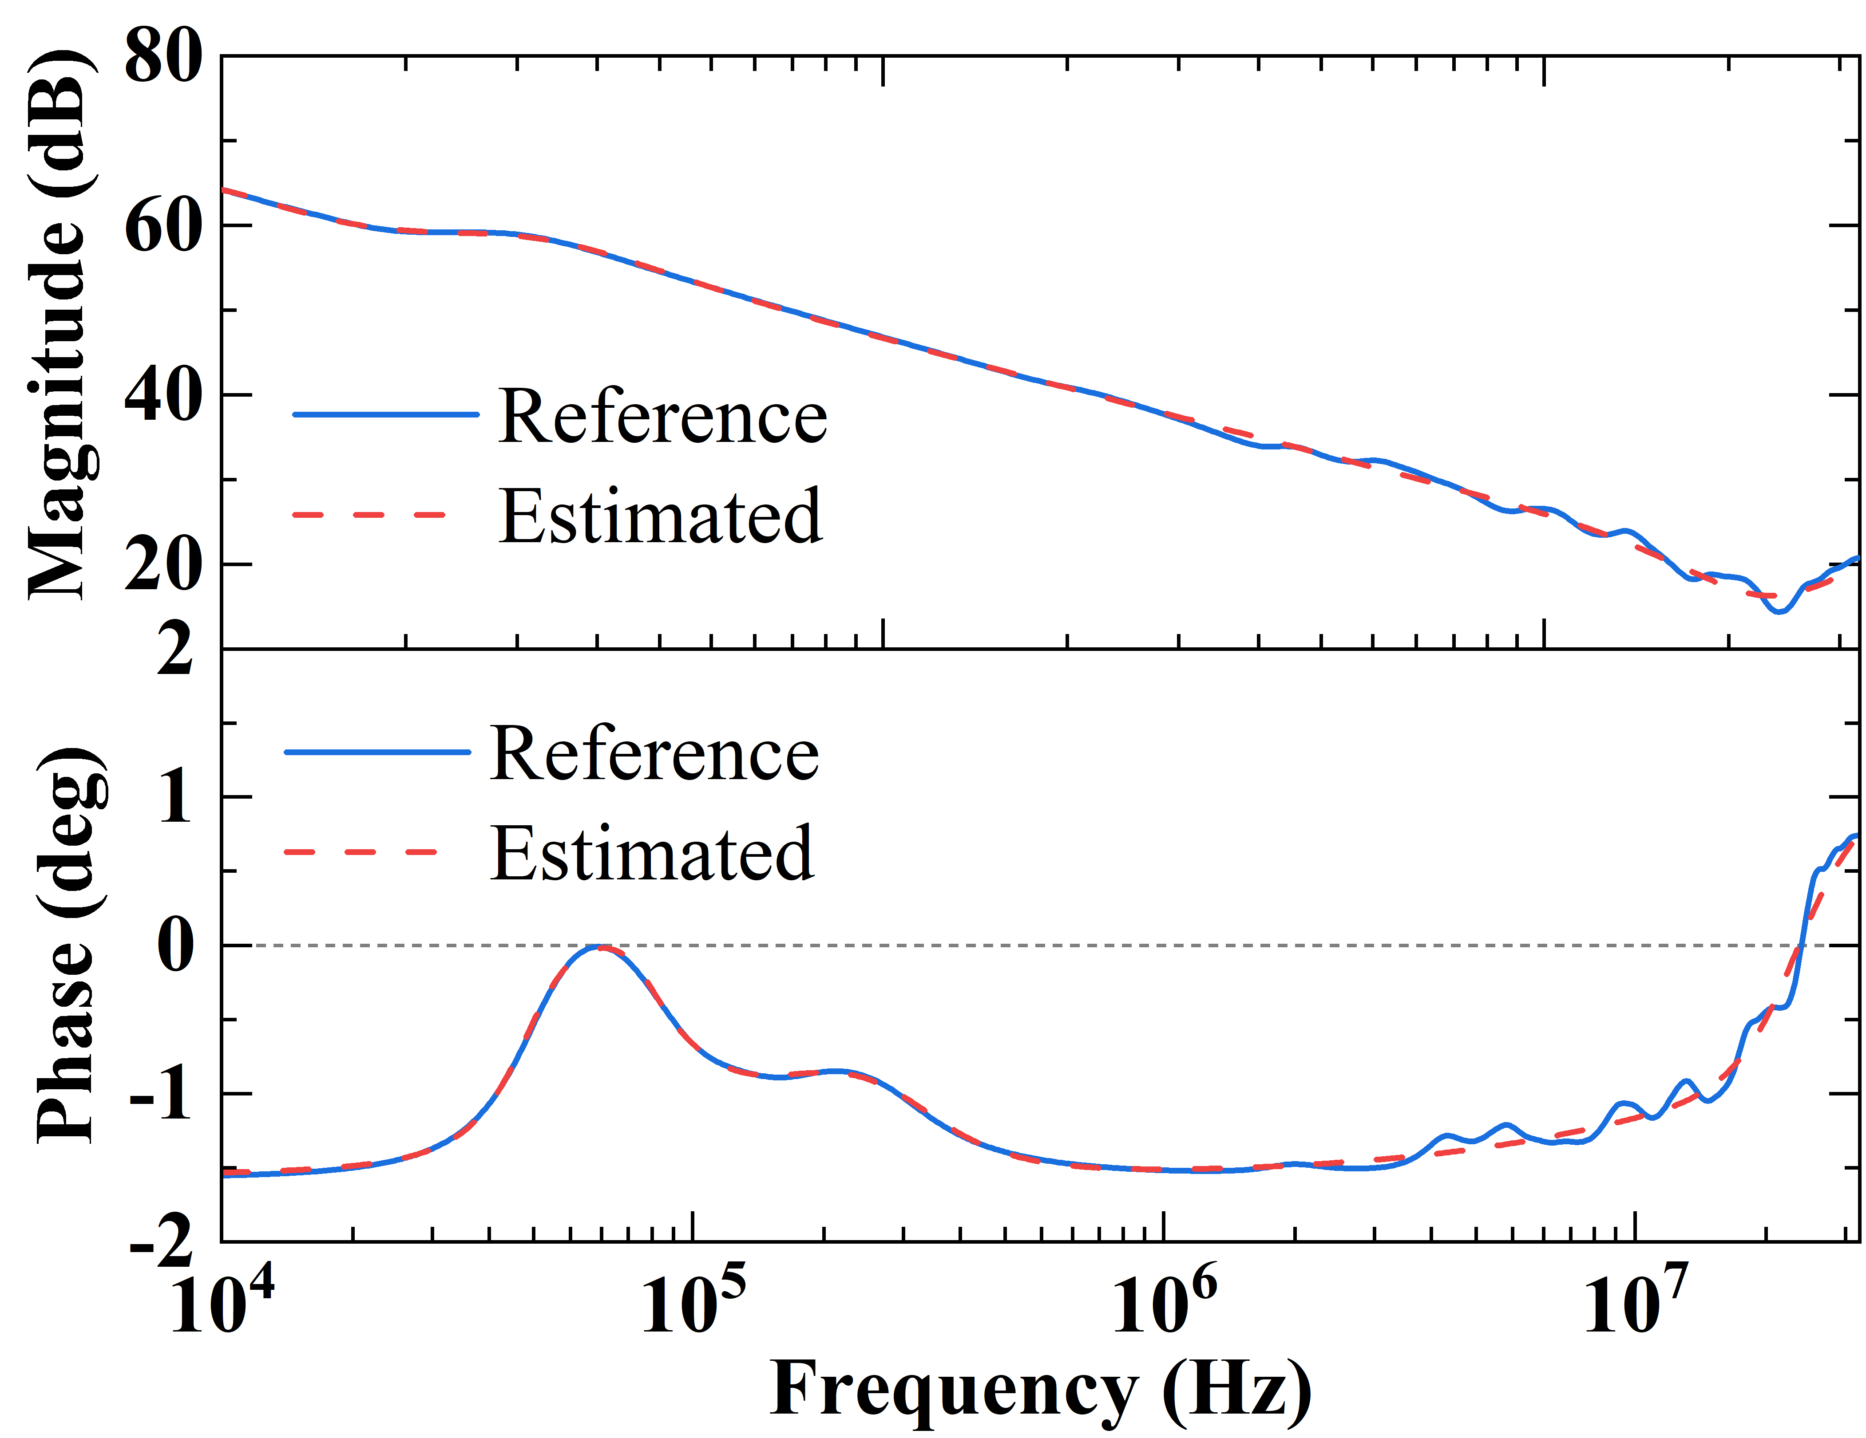

(c) (d)

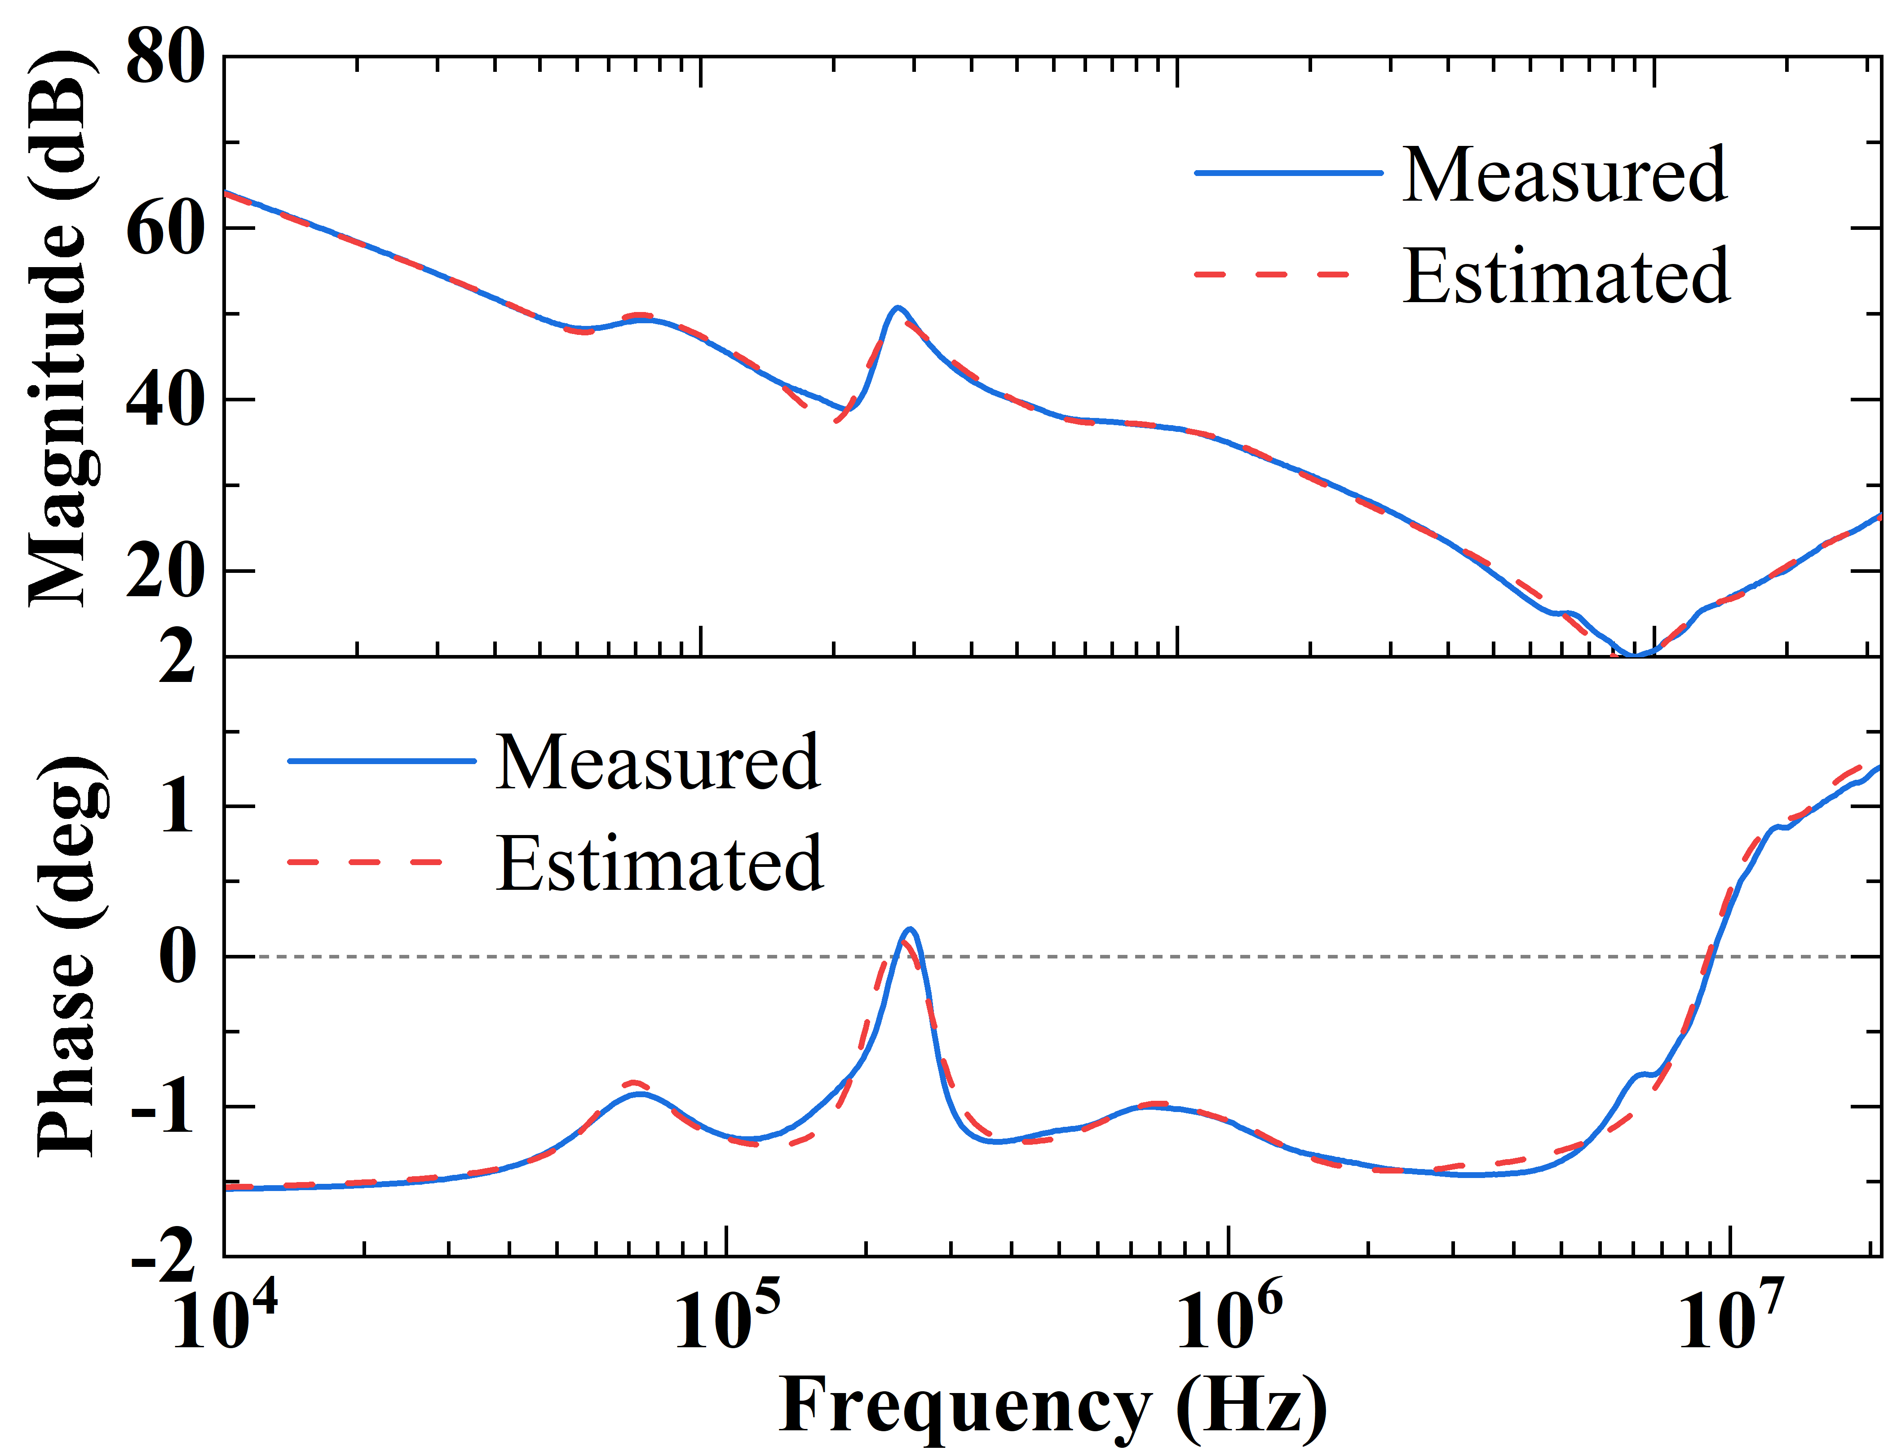 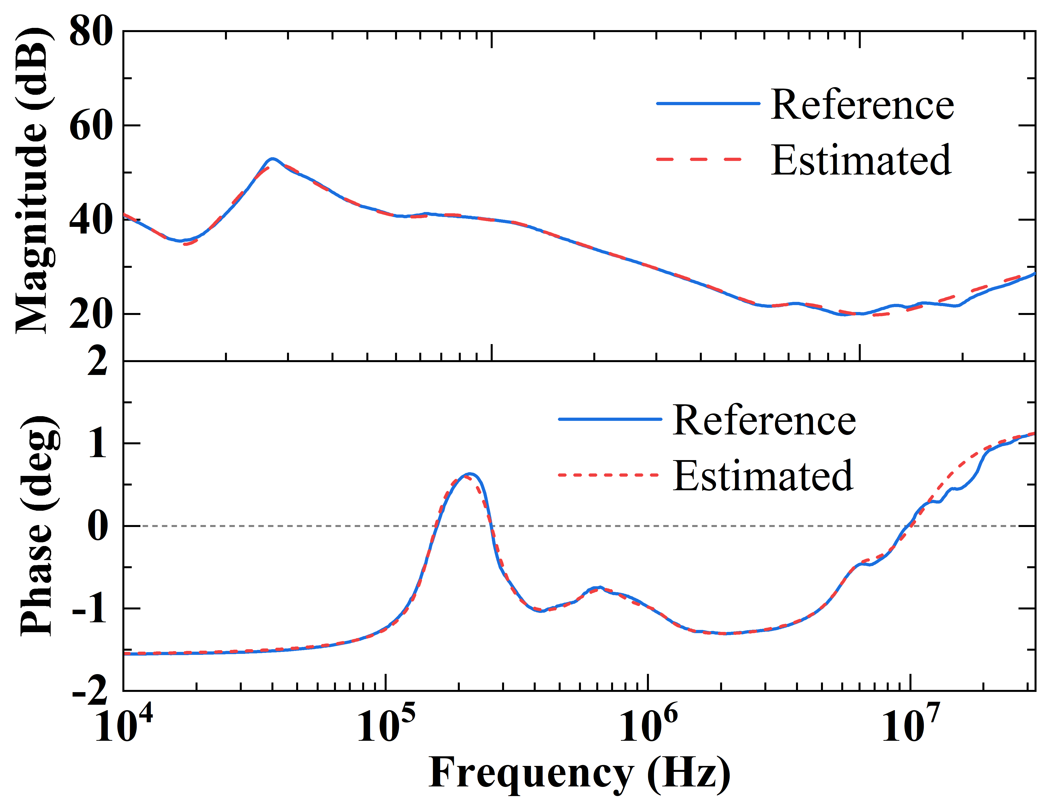

(e) (f)

Figure R3. (a) Model in [25]. (b) Proposed model with two levels. (c) Estimated CM impedance of a motor using the model in [25]. (d) Estimated CM impedance of a 1.1-kW motor (Y-connection) using the proposed model. (e) Estimated CM impedance of a 5.5-kW motor (∆-connection) using the proposed model. (f) Estimated CM impedance of a 22-kW motor using the proposed model.

Comparison between the proposed method and the methods reported in [30]:

Step 1: As shown in Figures R4(a) and R4(b), the model in [30] has a similar number of stages to the proposed model with four levels. Therefore, both models are used for comparison. The model in [30] validates the estimated CM and DM impedance magnitudes of two motors over the frequency range from 1 kHz to 100 MHz. To ensure a fair comparison, the same type of motor impedance magnitudes over the same frequency range are estimated using the proposed model. Considering the power ratings of the two motors used for validation in [30] are 3 kW and 11 kW, two motors with similar power ratings are selected for validating our proposed model.

Step 2: The estimated results for DM (Y-connection), CM (Y-connection), DM (∆-connection), and CM (∆-connection) impedance magnitudes of the two motors are shown in Figures R4(c) to R4(r). The respective measurement results are also included in the figures for reference. Using the measured results as references, the averaged magnitude relative error (*ema*) of the above impedances using the proposed model is listed in Table R3, which remains rather low; while the *ema* of the model in [30] is not mentioned. As seen, there are some relative significant deviations at high frequencies above 30 MHz for the estimated results using the model in [30], particularly those shown in Fig. R4(k) and R4(m). This is because, as frequency increases, the motor impedance curve in the high-frequency region (above 30 MHz) will have many local variations. Using an analytical method often makes it difficult to consider all these local variations. Therefore, the “Accuracy” of the method reported in [30] is listed as “Moderate” in Table I.

Table R3. Errors of the estimated CM and DM impedance magnitudes using the proposed model

|  |  |  |  |  |  |
| --- | --- | --- | --- | --- | --- |
| Motor power rating | Frequency range | *ema* (dB) | | | |
| CM (Y) | CM (Δ) | DM (Y) | DM (Δ) |
| 5.5 kW | 100 Hz-100 MHz | 0.31 | 0.36 | 0.10 | 0.09 |
| 22 kW | 100 Hz-100 MHz | 0.25 | 0.26 | 0.12 | 0.14 |

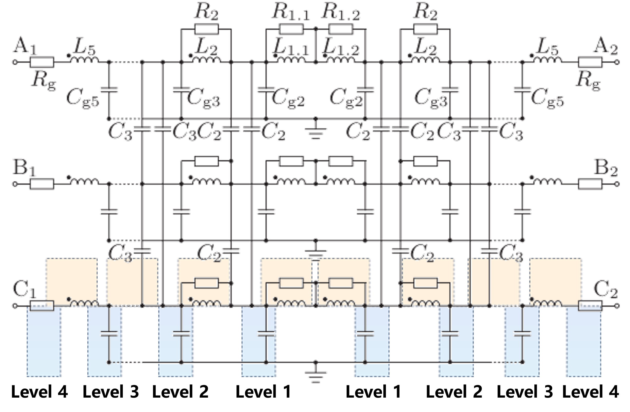 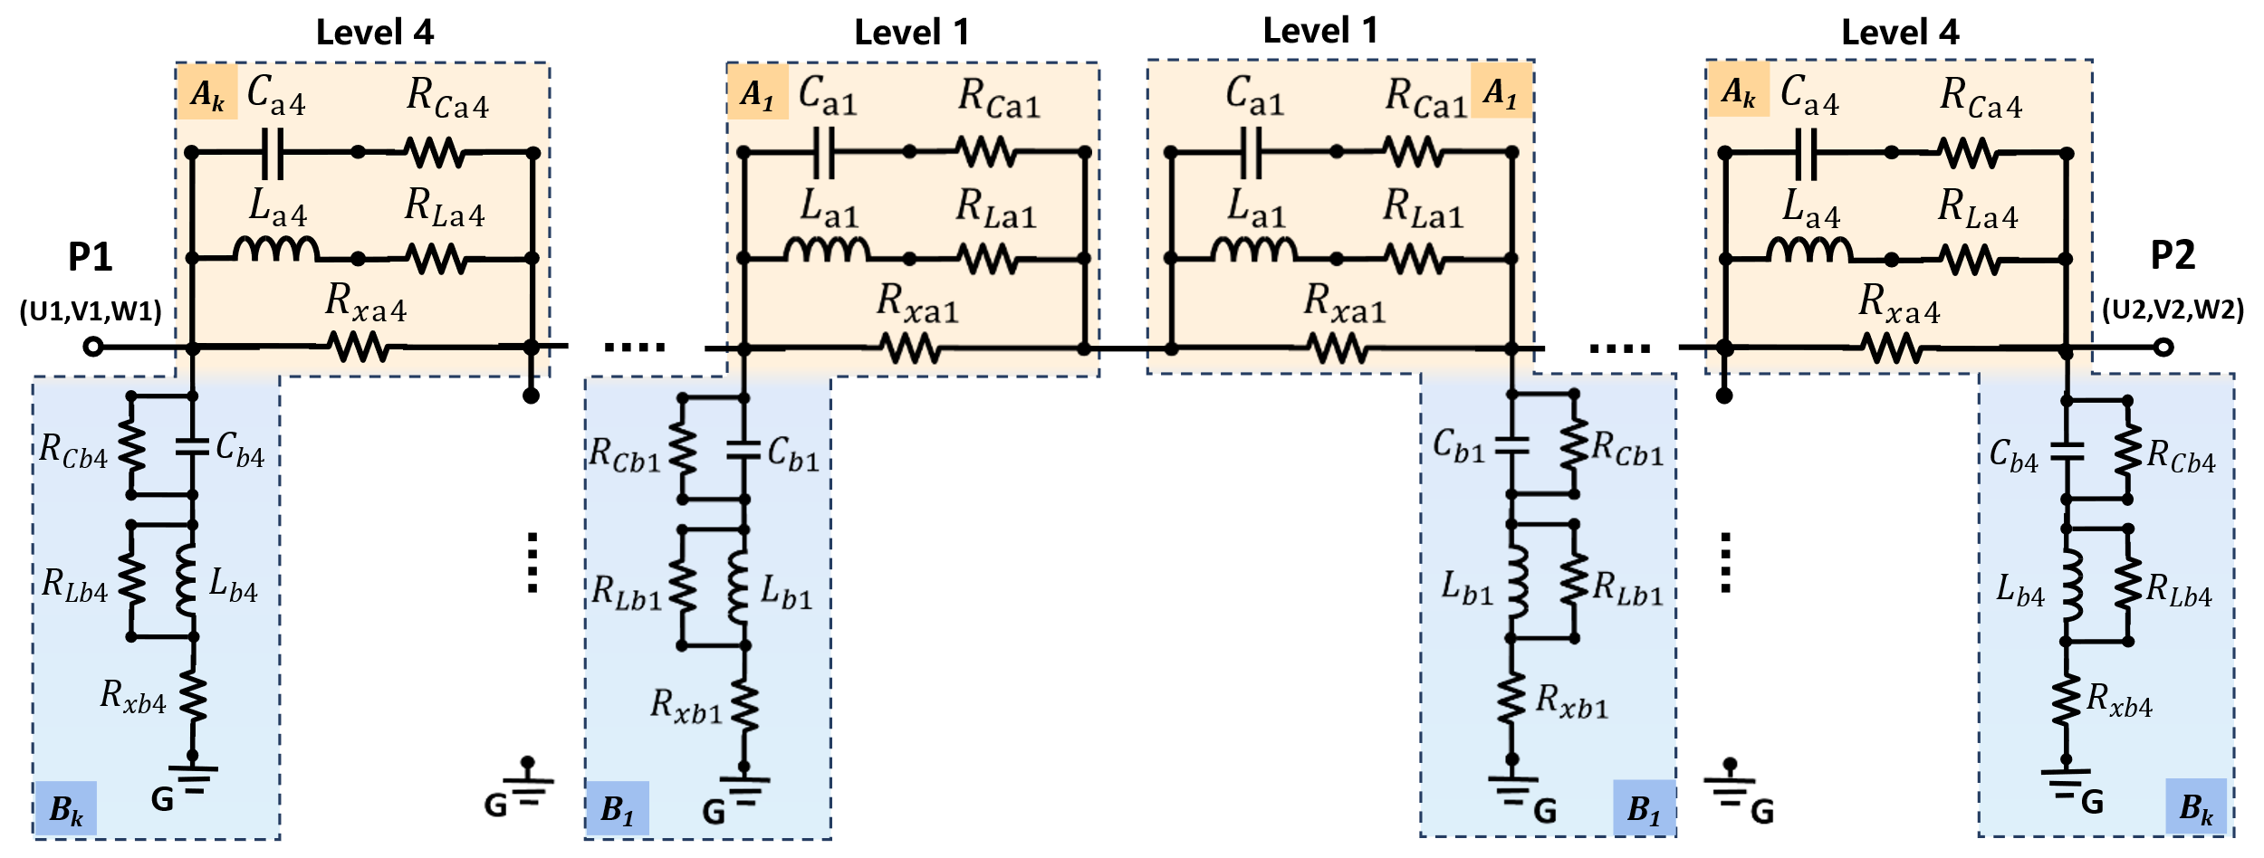

(a) (b)

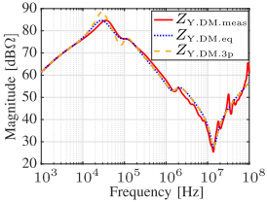 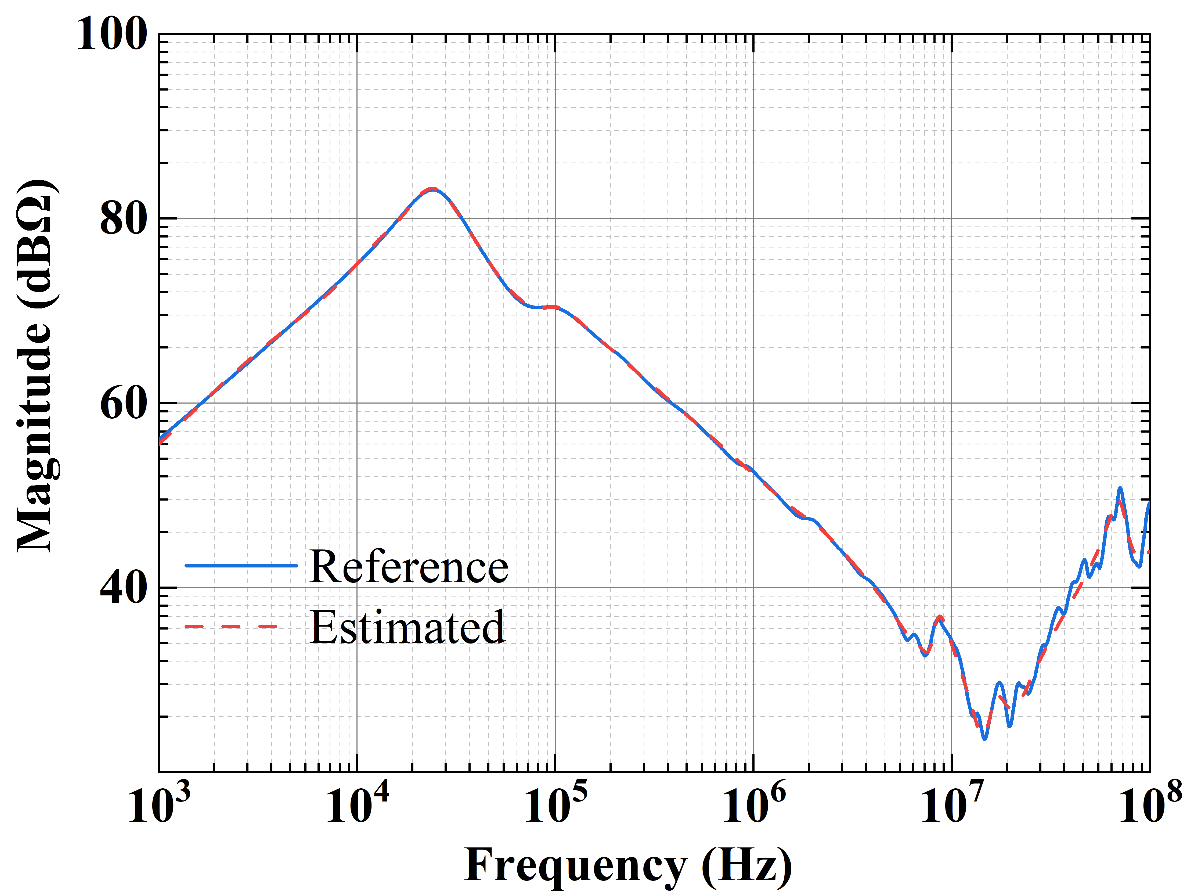

(c) (d)

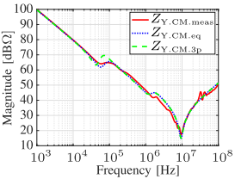 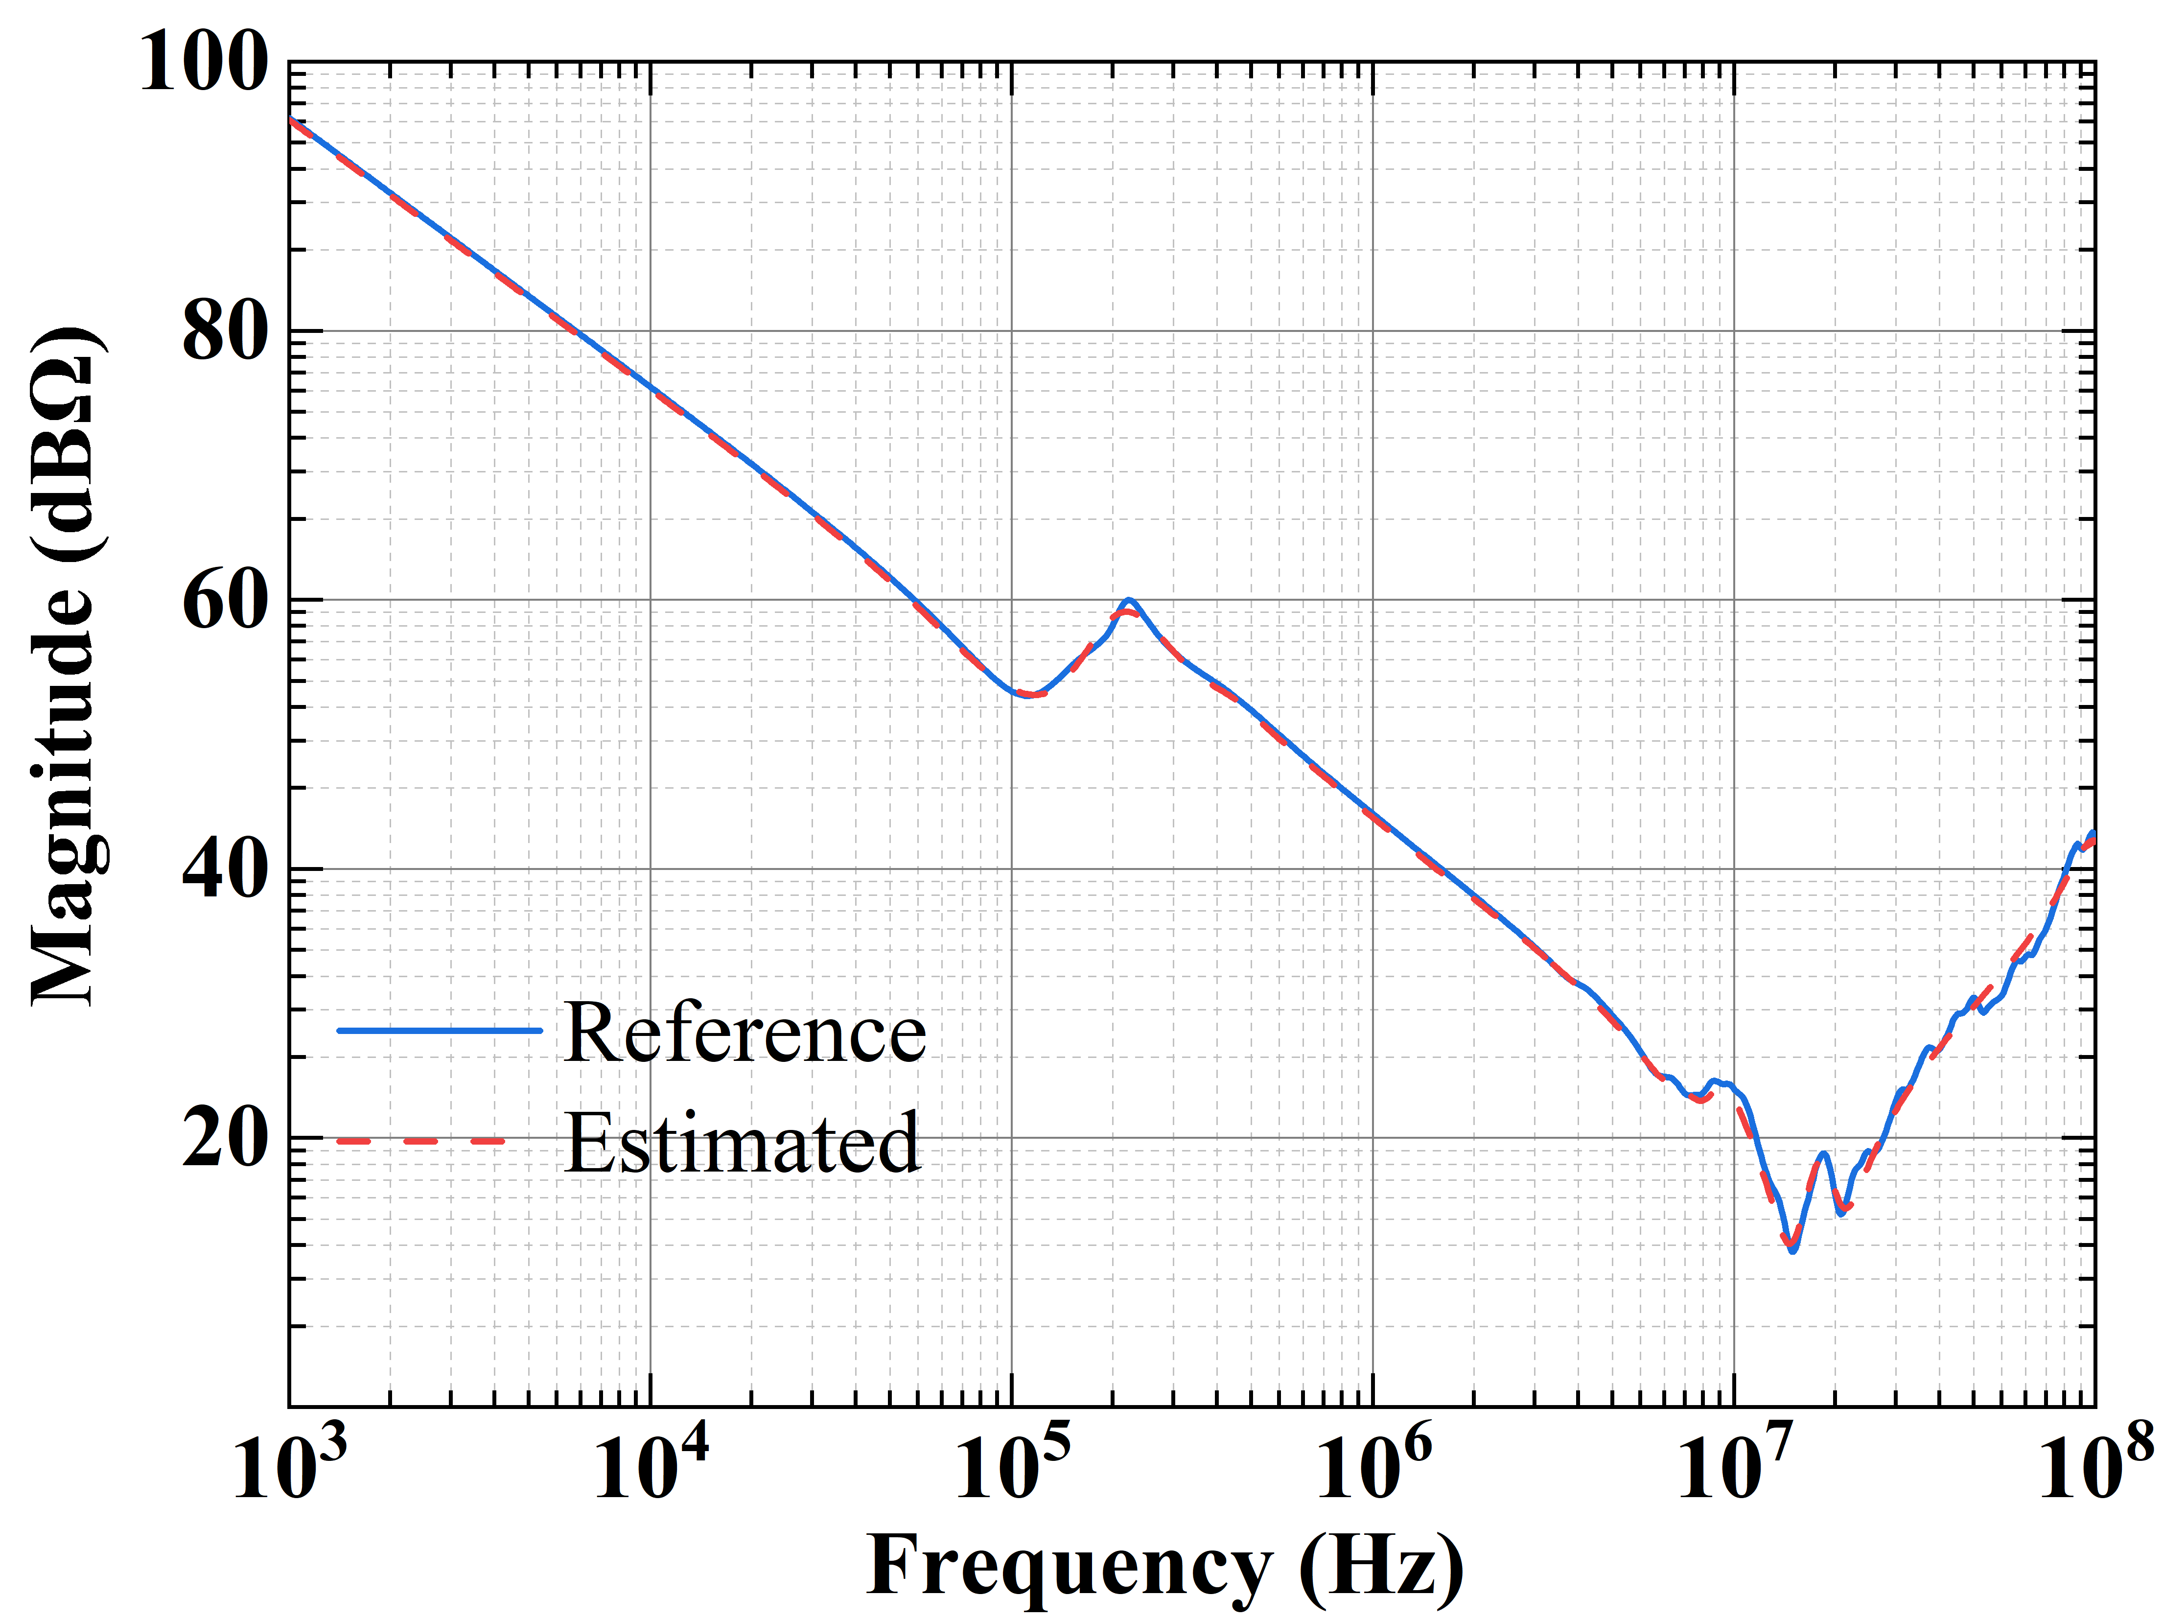

(e) (f)

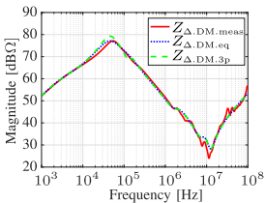 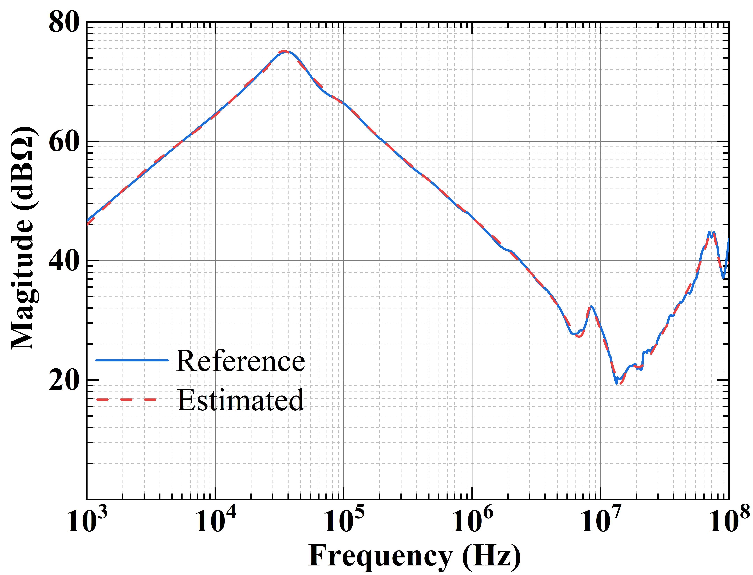

(g) (h)

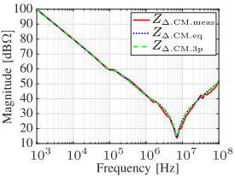 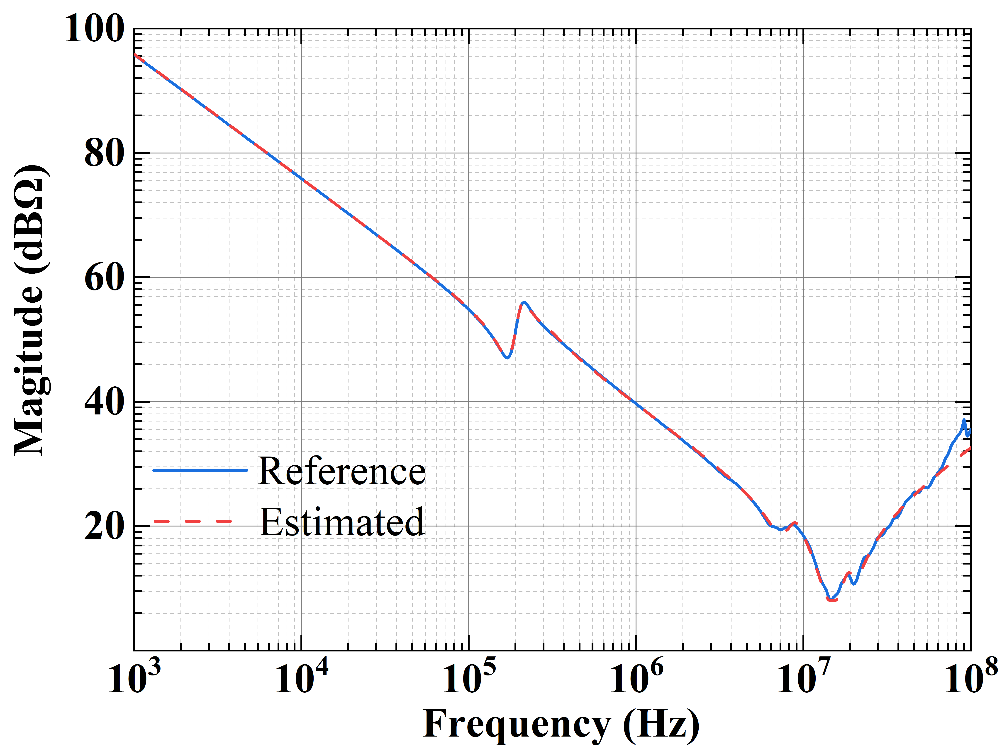

(i) (j)

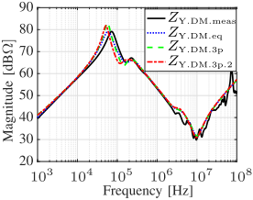 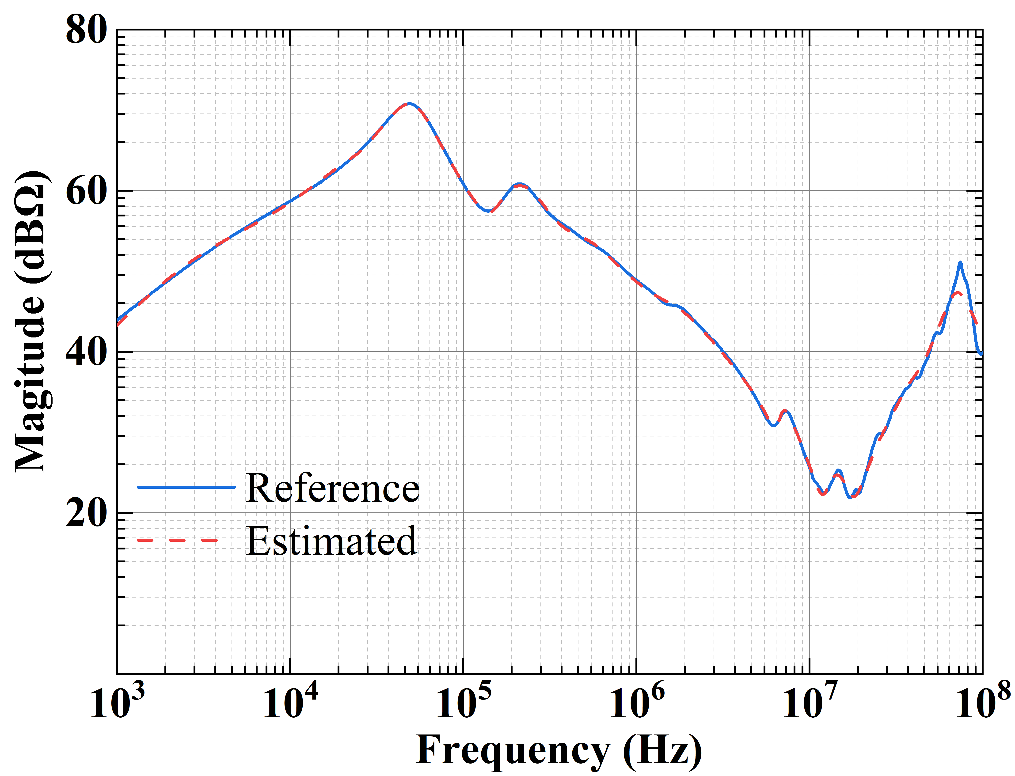

(k) (l)

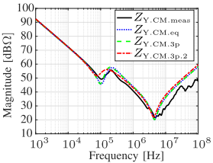 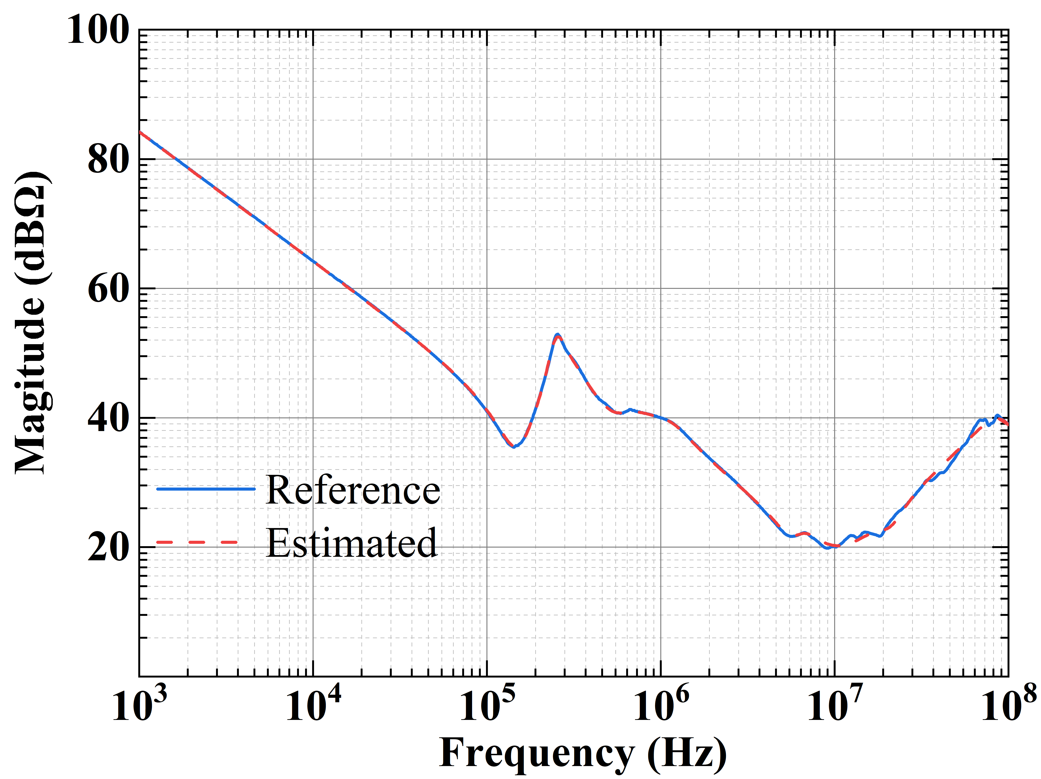

(m) (n)

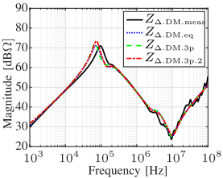 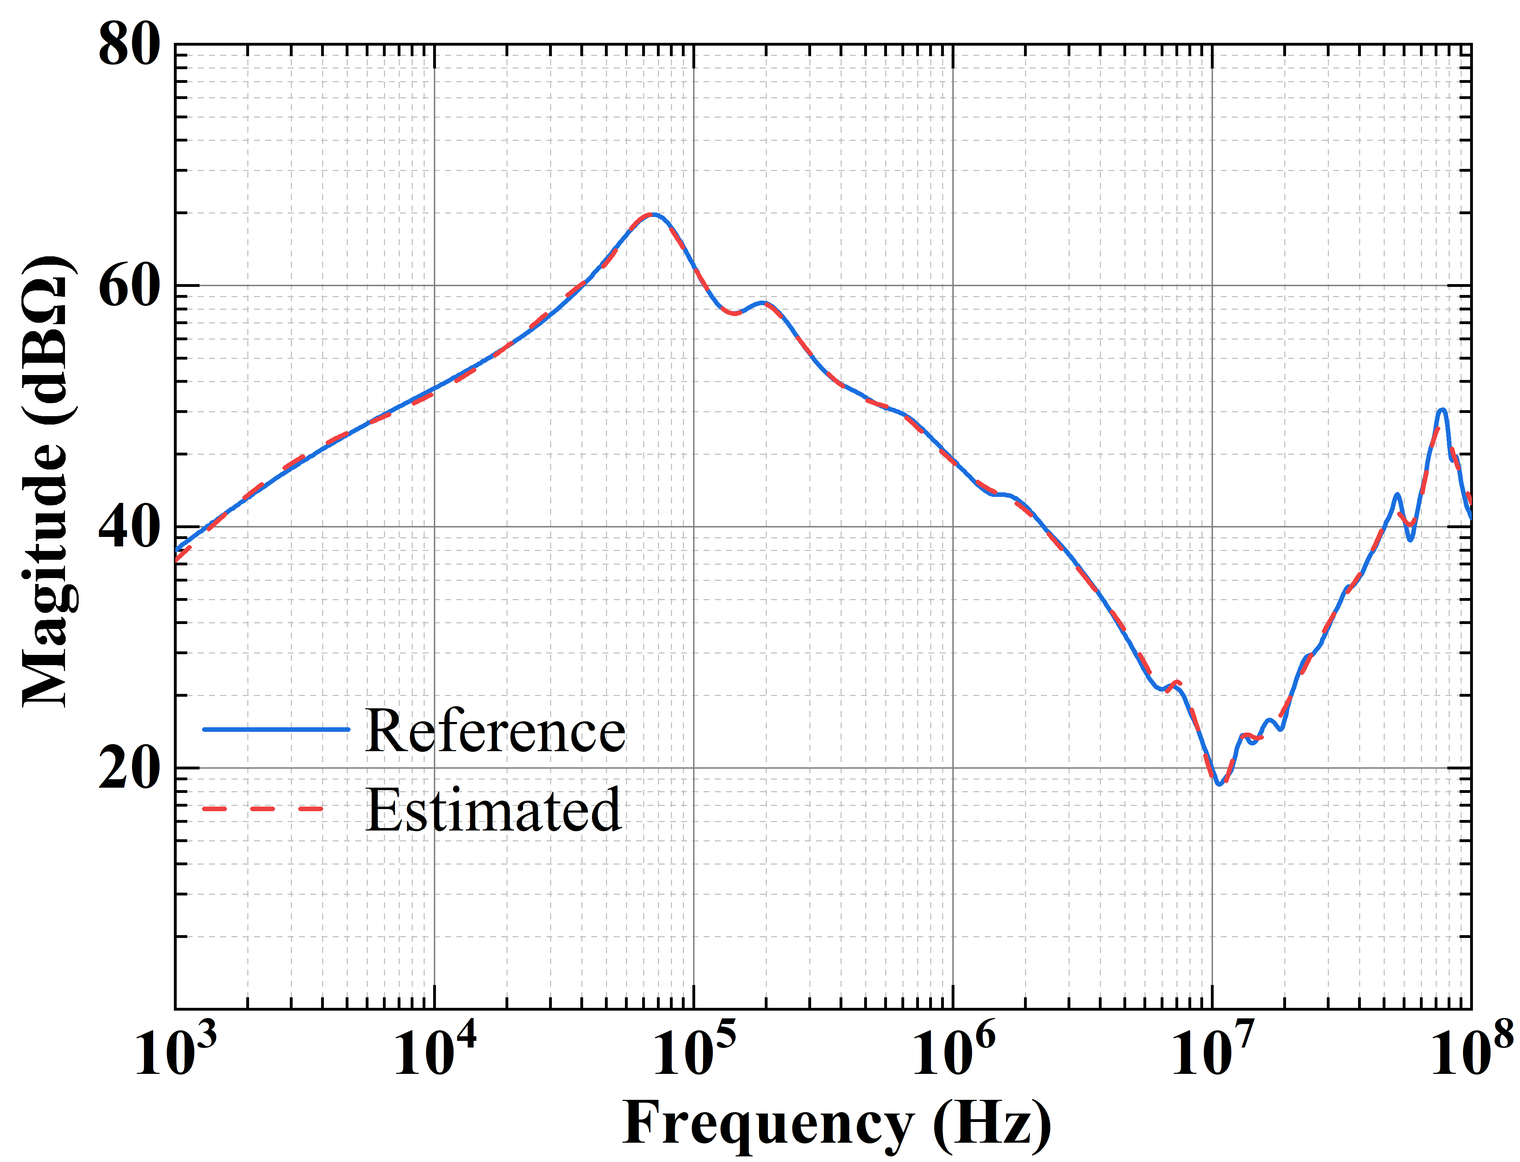

(o) (p)

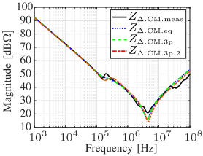 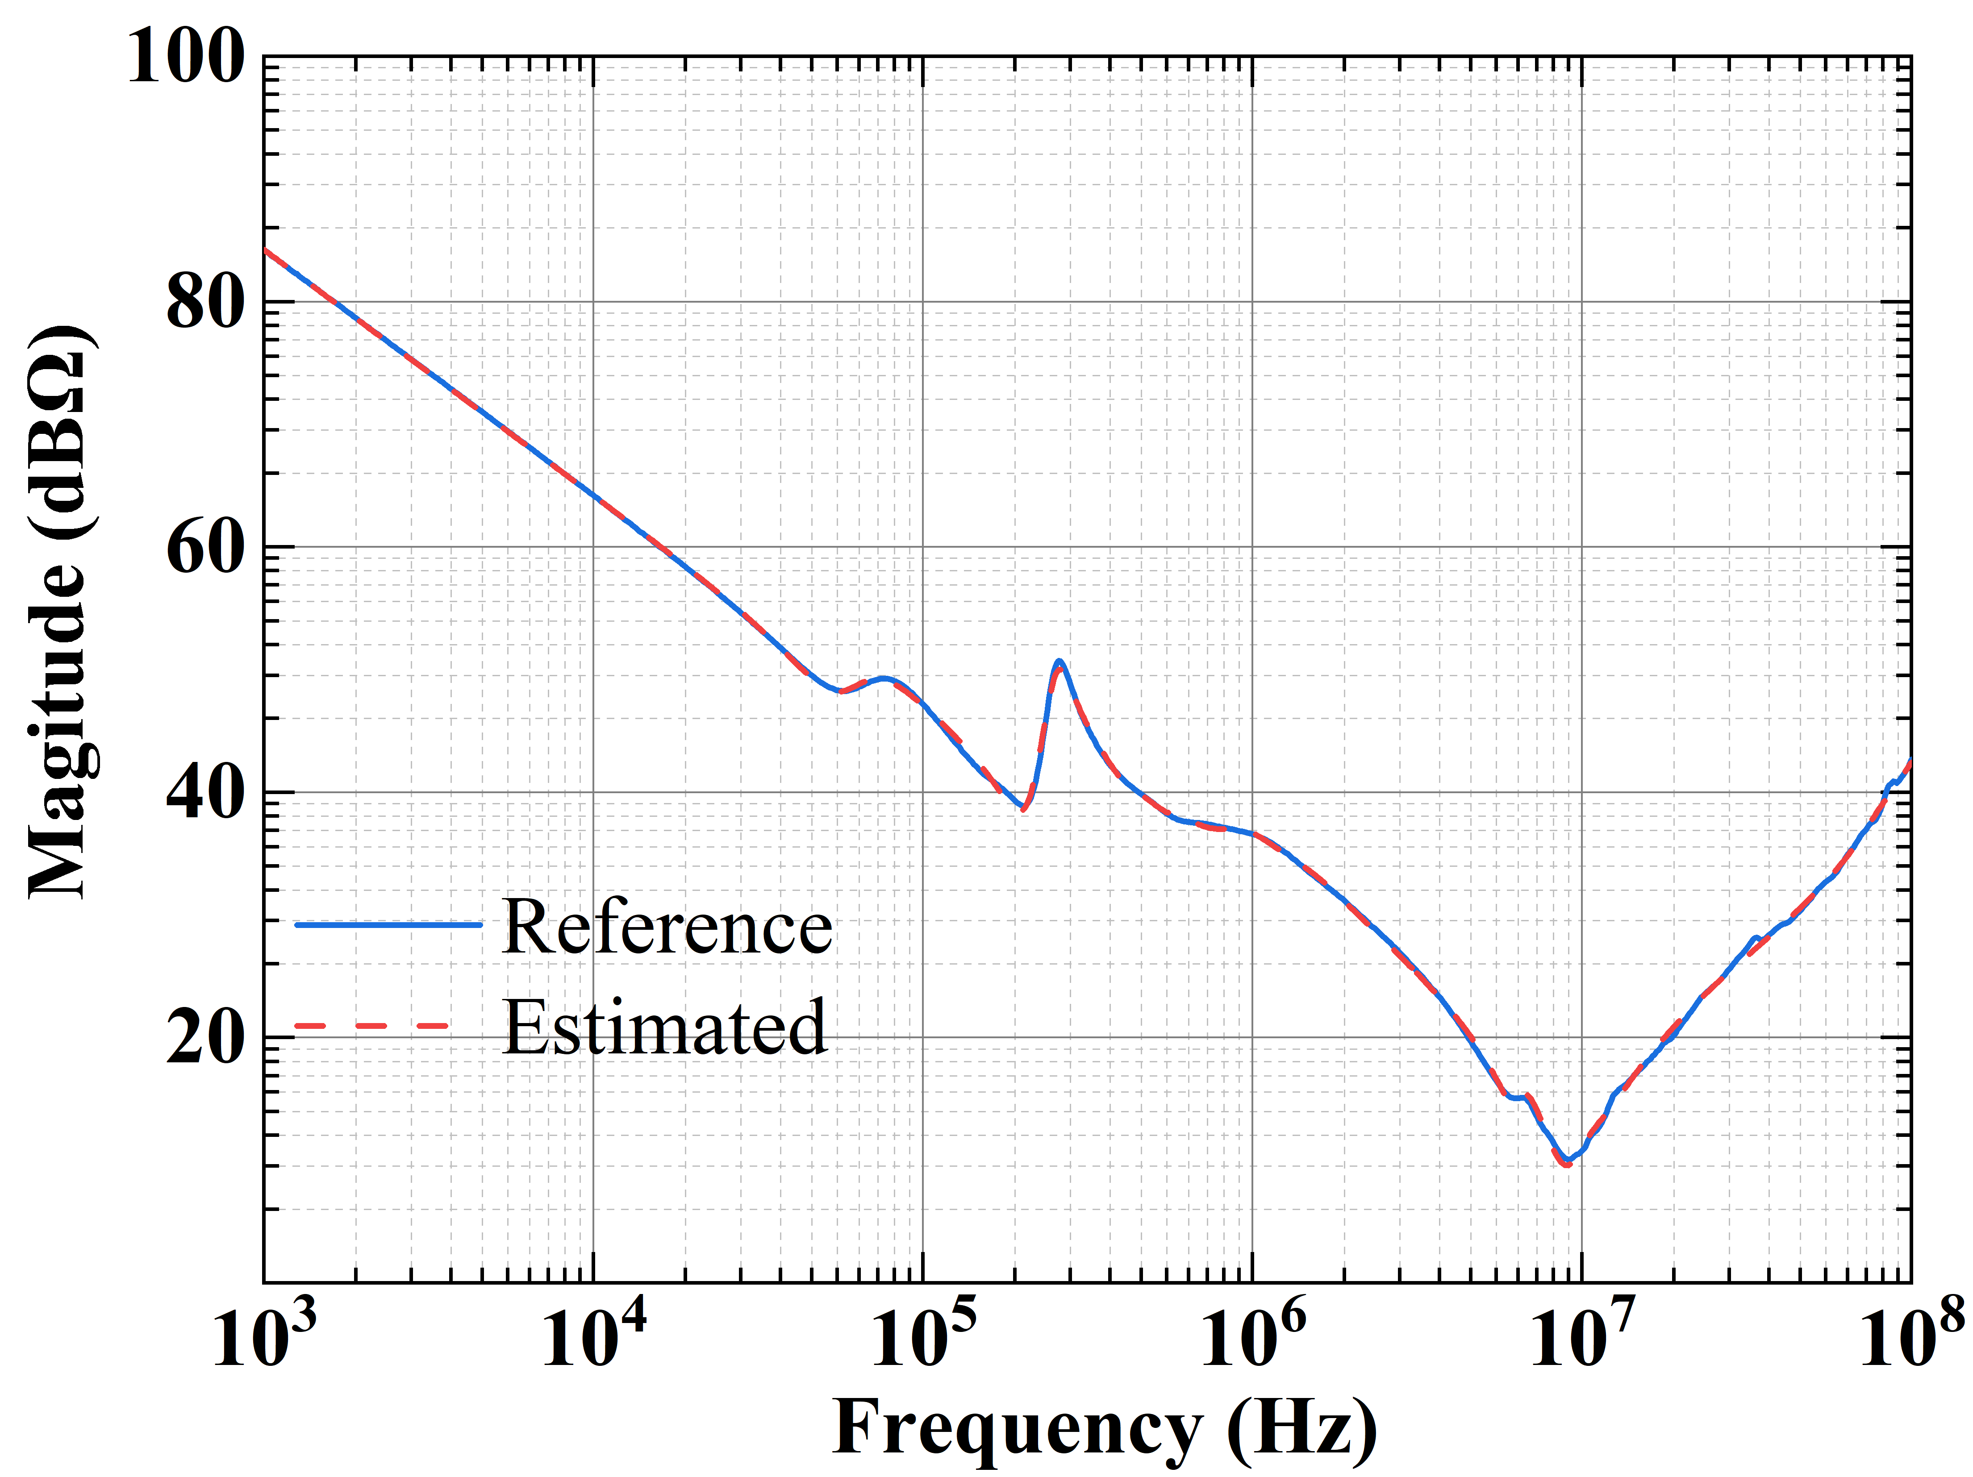

(q) (r)

Figure R4. (a) Model in [30]. (b) Proposed model with four levels. (c) Estimated DM impedance of a 3-kW motor (Y-connection) using the model in [30]. (d) Estimated DM impedance of a 5.5-kW motor (Y-connection) using the proposed model. (e) Estimated CM impedance of a 3-kW motor (Y-connection) using the model in [30]. (f) Estimated CM impedance of a 5.5-kW motor (Y-connection) using the proposed model. (g) Estimated DM impedance of a 3-kW motor (Δ-connection) using the model in [30]. (h) Estimated DM impedance of a 5.5-kW motor (Δ-connection) using the proposed model. (i) Estimated CM impedance of a 3-kW motor (Δ-connection) using the model in [30]. (j) Estimated CM impedance of a 5.5-kW motor (Δ-connection) using the proposed model. (k) Estimated DM impedance of a 11-kW motor (Y-connection) using the model in [30]. (l) Estimated DM impedance of a 22-kW motor (Y-connection) using the proposed model. (m) Estimated CM impedance of a 11-kW motor (Y-connection) using the model in [30]. (n) Estimated CM impedance of a 22-kW motor (Y-connection) using the proposed model. (o) Estimated DM impedance of a 11-kW motor (Δ-connection) using the model in [30]. (p) Estimated DM impedance of a 22-kW motor (Δ-connection) using the proposed model. (q) Estimated CM impedance of a 11-kW motor (Δ-connection) using the model in [30]. (r) Estimated CM impedance of a 22-kW motor (Δ-connection) using the proposed model.